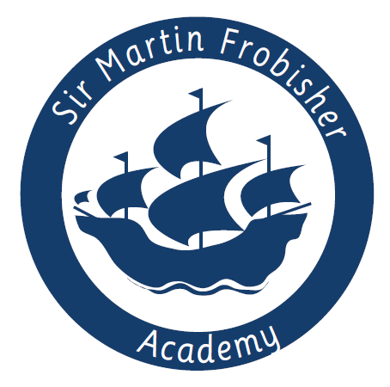
Class Teacher Vacancy

Overview
Are you an outstanding Practitioner? Do you want the opportunity to really make a difference to children’s lives? If so, our children need you! At Sir Martin Frobisher Academy we are looking for Class Teachers. We are looking for individuals who are up for a challenge and want to get stuck in with all aspects of our academy life!

Post Title: | Class Teacher
Contract type: | Permanent
Location: | Sir Martin Frobisher Academy
Working hours: | Full-time
Start date: | ASAP or 1st September 2020
Salary: | Main/Upper Pay Scale

About us
Sir Martin Frobisher serves the Jaywick community and many of our children are brought by bus to school from the Brooklands Estate on Jaywick Sands, the most deprived area in Britain. We currently have 247 children on roll.

After a year of intensive support from the Trust, the school secured a Requires Improvement Ofsted judgement in June 2019 and there is now a permanent new Leadership Team in place. There is no doubt about it, working at Sir Martin Frobisher requires passion, hard-work and dedication, but being part of our journey to good and beyond is exciting and will ensure that the children receive the high quality education they deserve and give the community we serve a school they can be proud of. To see more information about Sir Martin Frobisher, please visit our website.

The children at Sir Martin Frobisher need a stable and committed staff, who really believe in them and are willing to do whatever it takes to ensure they receive the best teaching and the widest opportunities possible. In return, you will see that our children are enthusiastic, keen to learn and rewarding to teach.

About the role
As a newly appointed member of the Sir Martin Frobisher family, you will help shape our future direction. You will work alongside our Senior Leadership Team and other Sir Martin Frobisher staff to help create an exciting and vibrant school, where all children thrive, regardless of their background.

You will work in partnership with other Class Teachers and Learning Support Assistants. You will be supported by experienced Senior Leaders and be part of the wider Academy Team.

There is potential for your role to grow and adapt with the academy over the coming years, with leadership opportunities as the school develops and improves. You will be expected to lead a curriculum subject area, unless you are an NQT.

What we’re looking for:
We are looking a good or outstanding classroom practitioner within either Key Stage One or Two. You will be someone who is highly driven and motivated, has an eye for detail, and can work flexible and creatively.
The successful candidate will have:
- The motivation and resilience to achieve the very best for the children in our care and be relentless in the pursuit of excellence
- Proven experience as an effective good and outstanding classroom teacher
- Experience of working with children of different ages within Key Stage One and Two
- Excellent communication skills and a good sense of humour
- A positive team player and be able to use your own initiative
In return we can offer:
- A firm commitment to you and your professional development
- Friendly, supportive, enthusiastic and hardworking colleagues, staff and Governors
- A growing learning community
- Encouragement to develop new ideas and the opportunity to make a real difference
-Coaching and mentoring from a member of academy’s Senior Leadership Team
-Fantastic trust-wide CPD opportunities
-Vast opportunities for career progression

How to apply
We hope you will take the time to find out more about our academy and experience our warm welcome. For further information about the role, or to arrange an informal discussion, please contact the school on 01255 427073 or email frobisher.admin@smfa.org.uk.

Completed applications should be sent via e-mail to frobisher.admin@smfa.org.uk by Monday 2nd March 2020.

Short-listed candidates will be invited for interviews on Friday 13th March 2020. Sir Martin Frobisher Academy is committed to safeguarding and promoting the welfare of children, young people and vulnerable adults and expects all staff and volunteers to share this commitment. The successful applicant will be subject to an enhanced DBS check.

In applying for this post you are required to submit:
- A completed REAch2 Academy Trust Application form which contains the Person Specification form; and
- A supporting letter of application; not to exceed two sides of A4
- Complete: Online Equality and Diversity Monitoring Form

