Monday
Approx. Timing | Suggested Activity | Activity Plan
10 mins | Mindfulness | This could be a colouring activity, a finger gym or a quiet handwriting exercise such as name writing Something that gets your child ready for a day of learning.
30 mins | Eat breakfast with family | This is where your child will have their bagels (if in school) If you are at home you could use this time to sit as a family and eat breakfast together. It is important to teach children how to hold a conversation or have good table manners.
15 mins | Staying safe and healthy | Use the link below to watch the ‘Baby Shark’ washing hands video. Remind your child/children about the importance of keeping their hands clean and key times to wash them – when we sneeze or cough, before we eat, after touching animals, after the toilet and when we gave played outside.  https://www.youtube.com/watch?v=L89nN03pBzI  If you would like to help your child to understand social distancing, you can use the link below to watch as the Play Mobil characters explain why we distance. You could even practise at home by asking your child to place their toys apart from each other.  https://www.youtube.com/watch?v=kyUh-b2q9MA
20 mins | Phonics/Reading and literacy | Reception: Use the flashcards to practice the speedy sounds. See how quickly you can say each one.  Reception should have flashcards for the sounds: m a s d t I n p g o c k u b f e l h sh r, j, v, y, w, z, x  - Make a new flashcard for the sound ‘th’.  - Introduce this sound to your child. When a sound has two letters, we call these best friends. When making this sound encourage your child to place their tongue between their teeth.  - Use the pictures for ‘th’ (scroll down) to practice saying the sound in words – thumb, throne, three.  - Next place your new ‘th’ flashcard in a pile with all the others sounds. Shuffle them up. Go through the sounds (speedy sounds) and ask your child to point to today’s sounds ‘th’ when they see it. Repeat and shuffle the sounds again.  - Practise writing the best friends ‘th’. t- down the tower, across the tower. h- down the head to his hooves and over his back.  - Collect the flash cards for the sounds th, i, n, w, s, o, m.  - You are now going to try and make some words and read them using Fred Talk.  - Say the words then work together to spell them using the flashcards – When reading a word encourage your child to spot the best friends first and say the best friends sound then read the whole word e.g. “best friends ‘th’. w-i-th with”.  with, thin, this, moth  Challenge: Try writing the words that use the ‘th’ sound.  Nursery: Practise the sounds using their flash cards: m a s d t  Hide and seek sounds – hide each of the sounds around your home and ask your child to find them all. When they find each sound encourage them to say the sound.
15-20 mins | Break Time
10 mins | Get active! | Time to get active!  Todays challenge: 10 star jumps, 15 hops, 30 seconds running on the spot (repeat twice).  Stretch: Stretch and see if you can touch the ceiling/sky. Reach down and touch the ground. Stretch out and try to touch the walls then swap and reach for the other side.  Finish with some deep breaths in and out and a cup of water.
25-30mins | Maths Activity | Reception: Count forwards and backwards to 20.  Nursery: Practise recognising numbers 1-5 then 1-10.  Reception and Nursey: This week you are going to be looking at patterns. Today we would like you to go for a walk or look around your home for environmental patterns. You may find patterns on the sides of houses made from the bricks, on a tree trunk, on flower petals, duvet covers, pillows or fences. Take pictures of the patterns that you find so that you can talk about them together again later.  When you arrive home look back at the picture you have take and talk together about what patterns they can see. It may be a colour pattern or a shape pattern.
10 mins | Washing hands ready for lunch  (at school children will wash hands one at a time so more time is needed)
30-40 mins | Lunch time
15 minutes | Staying safe and healthy | As in the session this morning – recap the song and remind your child about the importance of keeping our hands clean and our distance from others during this time at home (or at school).
25-30 mins | Topic/English Activity | This week we are thinking all about Growing.  If you have the story of ‘Jack and the Beanstalk’ you can use this to help with this week’s learning. You can also click on the link below to watch the story.  https://www.youtube.com/watch?v=W5rxfLRgXRE  Reception & Nursery: Read or share the story together. Ask your child questions as you share the story.  - What did Jack have to do with his cow? Why?  - Why did Jacks Mum get angry when he showed her the beans?  - How did Jack feel when he wakes up to a beanstalk?  - What did Jack do when he saw the beanstalk?  - Why did Jack go back up the beanstalk?  - How will the story end?
10 mins | Golden Mile/Physical Activity
15-20mins | Topic | This week our topic is all about Growing. Listen to the nursery rhyme ‘Mary quite contrary’ and sing together. Can you add actions to the song?  https://www.bbc.co.uk/teach/school-radio/nursery-rhymes-mary-mary-quite-contrary/zdtj47h  Look out of your window or go into your garden and look at all the things that are growing such as the grass, flowers, trees and weeds. Talk about how they think they grow.
20-30mins | Learning and play time | Spend time with your child as they choose their own toys to play with. Take the time to talk to them about their game and join in the play. Ask them what they are playing/making? How did they make it? What is it? How do you play? What makes it special? Ask them about their day and what they have enjoyed. Is there anything they would like to do again? What would they like to do tomorrow?  Spending quality time together is important and creates lots of memories for your child.
10-20 mins | Story time/Read a text  If you can’t find any books to read then you could make up your own stories together OR sing a nursery rhyme or favourite song.
Tuesday
Approx. Timing | Suggested Activity | Activity Plan
10 mins | Mindfulness | This could be a colouring activity, a finger gym or a quiet handwriting exercise such as name writing Something that gets your child ready for a day of learning.
30 mins | Eat breakfast with family | This is where your child will have their bagels (if in school) If you are at home you could use this time to sit as a family and eat breakfast together. It is important to teach children how to hold a conversation or have good table manners.
20 mins | Staying safe and healthy | Use the link below to watch the NHS washing hands video. Remind your child/children about the importance of keeping their hands clean and key times to wash them – when we sneeze or cough, before we eat, after touching animals, after the toilet and when we gave played outside.  https://www.youtube.com/watch?v=S9VjeIWLnEg
20 mins | Phonics/Reading and literacy | Reception: Use the new flashcards to practise the speedy sounds. See how quickly you can say each one.  Reception should now have flashcards for m a s d t I n p g o c k u b f e l h sh r, j, v, y, w, z, x  Handwriting – Practise forming the following letters correctly  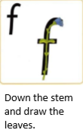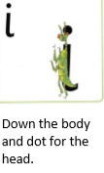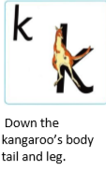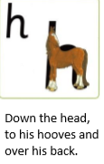  Nursery: Practise the sounds using their flash cards: m a s d t  Ask your child to try and draw different shapes and patterns such as circles, zig-zags, swirls etc.  Practise writing their name by tracing over the letters. Challenge them to write their name independently.
15-20 mins | Break Time
10 mins | Get active! | Time to get active!  Todays challenge: 30 seconds jumping on the spot, 10 jumping jacks, 30 seconds running with high knees on the spot (repeat twice).  Stretch: Stretch and make yourself look like a giraffe, make yourself as small as a mouse, as wide as a hippo.  Finish with some deep breaths in and out and a cup of water.
25-30mins | Maths Activity | Reception: Say or show your child three numbers and ask them to say the next number.  123….. 7 8 9…. 9 10 11….. 15 16 17 …..  Nursery: Practise recognising numbers 1-5 then 1-10.  Reception and Nursery: For this activity you will need items that your child can make a ‘AB’ pattern out of such as animal toys, Lego, coloured blocks and shapes.  An ‘AB’ pattern means the child will use just two things one after the other repeatedly.  Model to your child how to create a simple pattern e.g. cow, pig, cow, pig.  Red brick, yellow brick, red brick, yellow bricks.  Ask your child to say their pattern out loud to you so that they can hear the rhythm. See how many ‘AB’ patterns they can make.
10 mins | Washing hands ready for lunch  (at school children will wash hands one at a time so more time is needed)
30-40 mins | Lunch time
15 minutes | Staying safe and healthy | As in the session this morning – recap the song and remind your child about the importance of keeping our hands clean and our distance from others during this time at home (or at school).
25-30 mins | Topic/English Activity | See if your child can remember what story you shared yesterday (Jack and the Beanstalk).  Scroll down to find characters from the story. Cut them out and make them into puppets. Ask your child to re-tell the story to you. Encourage them to use key story language such as “Once upon a time, Fee-fi-foe-thumb”.  Remember to always supervise your child when using and scissors.
10 mins | Golden Mile/Physical Activity
15-20mins | Topic | Plant hunt: Take a walk around your local area and use the ‘Common British Plant’ checklist to see how many kinds of plant you can find (scroll down to find the checklist).
20-30mins | Learning and play time | Spend time with your child as they choose their own toys to play with. Take the time to talk to them about their game and join in the play. Ask them what they are playing/making? How did they make it? What is it? How do you play? What makes it special? Ask them about their day and what they have enjoyed. Is there anything they would like to do again? What would they like to do tomorrow?  Spending quality time together is important and creates lots of memories for your child.
10-20 mins | Story time/Read a text  If you can’t find any books to read then you could make up your own stories together OR sing a nursery rhyme or favourite song
Wednesday
Approx. Timing | Suggested Activity | Activity Plan
10 mins | Mindfulness | This could be a colouring activity, a finger gym or a quiet handwriting exercise such as name writing Something that gets your child ready for a day of learning.
30 mins | Eat breakfast with family | This is where your child will have their bagels (if in school) If you are at home you could use this time to sit as a family and eat breakfast together. It is important to teach children how to hold a conversation or have good table manners.
20 mins | Staying safe and healthy | Use the link below to watch the ‘Baby Shark’ washing hands video. Remind your child/children about the importance of keeping their hands clean and key times to wash them – when we sneeze or cough, before we eat, after touching animals, after the toilet and when we gave played outside.  https://www.youtube.com/watch?v=L89nN03pBzI
20 mins | Phonics/Reading and literacy | Reception: Use the flashcards to practice the speedy sounds. See how quickly you can say each one.  Reception should have flashcards for the sounds: m a s d t I n p g o c k u b f e l h sh r, j, v, y, w, z, x  1.Make a new flashcard for the sound ‘ch’.  - Introduce this sound to your child. When a sound has two letters, we call these best friends.  When making this sound thrust your lips out and pretend to sneeze.  - Use the pictures for ‘ch’ (scroll down) to practice saying the sound in words – chips, chair, children.  - Next place your new ‘ch’ flashcard in a pile with all the others sounds. Shuffle them up. Go through the sounds (speedy sounds) and ask your child to point to today’s sound ‘ch’ when they see it. Repeat and shuffle the sounds again.  - Practise writing the best friends ‘ch’. c- curl around the caterpillar. h- down the head to his hooves and over his back.  - Collect the flash cards for the sounds ch, i,n, p, m, u, r  - You are now going to try and make some words and read them using Fred Talk.  - Say the words then work together to spell them using the flashcards – When reading a word encourage your child to spot the best friends first and say the best friends sound then read the whole word e.g. “best friends ‘ch’. ch-i-n chin”.  Chip, chin, much, rich  Challenge: Try writing the words that use the ‘ch’ sound.  Nursery: Practise the sounds using their flash cards: m a s d t  Find the sounds – place each of the flashcards around the room for your child to see. Each time you say a sound your child needs to go to the sound as quickly and safely as they can. Try to make it so they need to move around the room for each new sound you say.
W | Break Time
10 mins | Get Active! | Time to get active!  Work with your child to make different shapes with their body e.g. a small, tall, round, huge, wide, narrow shape. You could ask them to make themselves look like animals or objects. The important part is making BIG movements and stretched to help develop strength.  Finish with a cup of water.
25-30mins | Maths Activity | Reception: Show your child a numbers between 1-10/1-20. Ask your child to count on e.g. ‘5’ 6 7 8 9 10  Nursery: Practise recognising numbers 1-5 then 1-10.  Reception: Today you are going to try and make ‘ABC’ patterns using toys, objects or colours.  An ‘ABC’ pattern means that you will use three different colours/items one after the other repeatedly.  Model to your child first e.g. Red, yellow, blue, red, yellow, blue.  Ask your child to try and continue your example pattern and repeat if needed.  Now see if they can create their own ‘ABC’ patterns.  Nursery: Create some more ‘AB’ patterns using objects from around your home or toys. You could use some children’s poster paint to make fingerprint patterns e.g. blue, green, blue, green. Extend your child’s learning by completing the Reception task above.
10 mins | Washing hands ready for lunch  (at school children will wash hands one at a time so more time is needed)
30-40 mins | Lunch time
15 minutes | Staying safe and healthy | As in the session this morning – recap the song and remind your child about the importance of keeping our hands clean and our distance from others during this time at home (or at school).
25-30 mins | Topic/English Activity | Today you are going to see if you can order the story. Scroll down to find a story map and some pictures to order.  Reception: As your child orders the pictures of the story on the story map, they need to write down some labels to support the pictures e.g. Jack, Mum, Giant, beans. Use the method from phonics (Fred Fingers) to help your child spell the words. You could stick the pictures onto a larger piece of paper or into a notebook to help your child to write.  Nursery: As your child orders the pictures ask them to tell you what is happening. Once in order ask your child to re-tell you the story from beginning to end.
10 mins | Golden Mile/Physical Activity
15-20mins | Topic | Labelling parts of the plant: You can complete this activity by using the diagram created for you (scroll down to find this) OR you can use a real flower. Take time to look at the picture and talk about what your child can see. What parts of the flower can they name? Use the labels to fill in the blanks. If you can think of other parts of the flower to label such as pollen you can do this to extend the learning further.
20-30mins | Learning and play time | Spend time with your child as they choose their own toys to play with. Take the time to talk to them about their game and join in the play. Ask them what they are playing/making? How did they make it? What is it? How do you play? What makes it special? Ask them about their day and what they have enjoyed. Is there anything they would like to do again? What would they like to do tomorrow?  Spending quality time together is important and creates lots of memories for your child.
10-20 mins | Story time/Read a text  If you can’t find any books to read then you could make up your own stories together OR sing a nursery rhyme or favourite song
Thursday
Approx. Timing | Suggested Activity | Activity Plan
10 mins | Mindfulness | This could be a colouring activity, a finger gym or a quiet handwriting exercise such as name writing Something that gets your child ready for a day of learning.
30 mins | Eat breakfast with family | This is where your child will have their bagels (if in school) If you are at home you could use this time to sit as a family and eat breakfast together. It is important to teach children how to hold a conversation or have good table manners.
20 mins | Staying safe and healthy | Use the link below to watch a washing hands video. Remind your child/children about the importance of keeping their hands clean and key times to wash them – when we sneeze or cough, before we eat, after touching animals, after the toilet and when we gave played outside.  https://www.youtube.com/watch?v=dDHJW4r3elE
20 mins | Phonics/Reading and literacy | Reception: Use the flashcards to practice the speedy sounds. See how quickly you can say each one.  Reception should have flashcards for the sounds: m a s d t I n p g o c k u b f e l h sh r j v y w z x  Handwriting – Practise forming the following letters correctly  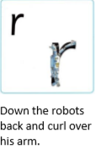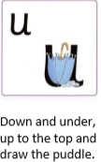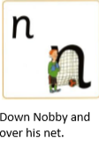  Nursery: Practise the sounds using their flash cards: m a s d t  Practise writing their name using their name cards.
15-20 mins | Break Time
10 mins | Get active! | Time to get active!  Todays challenge: 15 star jumps, 20 hops, 30 seconds running on the spot (repeat twice).  Stretch: Stretch and see if you can touch the ceiling/sky. Reach down and touch the ground. Stretch out and try to touch the walls then swap and reach for the other side.  Finish with some deep breaths in and out and a cup of water.
25-30mins | Maths Activity | Reception: Practise numbers 1-20 using flashcards.  Today we would like you to try and make ‘AABB’ patterns. For example, red, red, blue, blue, red, red, blue, blue. Share an example with your child first and ask them to continue the pattern. Repeat if needed to help understanding. Ask you child if they can create some ‘AABB’ patterns of their own.  Nursery: Ask your child to count out loud to see how high they can count.  Body patterns – Today you are going to work with your child to create patterns using actions e.g. tapping your head, then knees, head, knees, head, knees OR jump, hop, jump, hop.  How many different body patterns can you make?
10 mins | Washing hands ready for lunch  (at school children will wash hands one at a time so more time is needed)
30-40 mins | Lunch time
15 minutes | Staying safe and healthy | As in the session this morning – recap the song and remind your child about the importance of keeping our hands clean and our distance from others during this time at home (or at school).
25-30 mins | Topic/English Activity | Reception: In the story Jack climbs to the top of the beanstalk and discovers a castle. If you found a beanstalk and climbed to the top, what would you like to find? Example: a sweet land, water park, rollercoaster, chocolate factory. You can use the writing template below to draw and write down your ideas. Use the method from phonics (Fred Fingers) to help your child spell the words.  Nursery: Act out the story with your child at home. See if they can remember key parts of the story and direct your family to play and act out key roles. Encourage them to use the repetitive phrase such as “Fee-fi-foe-thumb”.
10 mins | Golden Mile/Physical Activity
15-20mins | Topic | 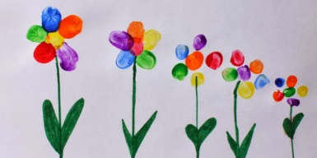  Rainbow Fingerprint flowers: Today you will need a selection of children’s coloured paint, card or paper and fingers! Support your child in creating rainbow flowers using the tips of their fingers to create the petals. Use paint or pencils to create the stem and leaves. You could make this into a card for someone special and give it as a gift. It may be someone you have not been able to see in a while. Don’t forget to write inside and send a lovely message.
20-30mins | Learning and play time | Spend time with your child as they choose their own toys to play with. Take the time to talk to them about their game and join in the play. Ask them what they are playing/making? How did they make it? What is it? How do you play? What makes it special? Ask them about their day and what they have enjoyed. Is there anything they would like to do again? What would they like to do tomorrow?  Spending quality time together is important and creates lots of memories for your child.
10-20 mins | Story time/Read a text  If you can’t find any books to read then you could make up your own stories together OR sing a nursery rhyme or favourite song
Friday
Approx. Timing | Suggested Activity | Activity Plan
10 mins | Mindfulness | This could be a colouring activity, a finger gym or a quiet handwriting exercise such as name writing Something that gets your child ready for a day of learning.
30 mins | Eat breakfast with family | This is where your child will have their bagels (if in school) If you are at home you could use this time to sit as a family and eat breakfast together. It is important to teach children how to hold a conversation or have good table manners.
20 mins | Staying safe and healthy | Use the link below to watch the ‘Germ Busters’ washing hands video. Remind your child/children about the importance of keeping their hands clean and key times to wash them – when we sneeze or cough, before we eat, after touching animals, after the toilet and when we gave played outside.  https://www.youtube.com/watch?v=07YNCFlS0iI  If you would like to help your child to understand social distancing, you can use the link below to watch as the Play Mobil characters explain why we distance. You could even practise at home by asking your child to place their toys apart from each other.  https://www.youtube.com/watch?v=kyUh-b2q9MA
20 mins | Phonics/Reading and literacy | Reception: Use the flashcards to practice the speedy sounds. See how quickly you can say each one.  Reception should have flashcards for the sounds: m a s d t I n p g o c k u b f e l h sh r, j, v, y, w, z, x  1.Make a new flashcard for the sound ‘qu’.  - Introduce this sound to your child. When a sound has two letters, we call these best friends.  When making this sound thrust your lips out and pretend to sneeze.  - Use the pictures for ‘qu’ (scroll down) to practice saying the sound in words – queen, quilt, quill  - Next place your new ‘qu’ flashcard in a pile with all the others sounds. Shuffle them up. Go through the sounds (speedy sounds) and ask your child to point to today’s sound ‘qu’ when they see it. Repeat and shuffle the sounds again.  - Practise writing the best friends ‘qu’. q – round her head, up past her earing, down her hair and flick. u – down and under, up to the top and draw the puddle.  - Collect the flash cards for the sounds qu, i, t, z, a, ck, l  - You are now going to try and make some words and read them using Fred Talk.  - Say the words then work together to spell them using the flashcards – When reading a word encourage your child to spot the best friends first and say the best friends sound then read the whole word e.g. “best friends ‘qu’. qu-i-t quit’  Quick, quiz, quit, quack, quilt  Challenge: Try writing the words that use the ‘qu’ sound.  Nursery: Practise the sounds using their flash cards: m a s d t  Spend some time reading with your child, pause in places to ask your child what happens next and how they think the story will end. Alternatively, if it is a story your child knows well ask them to read you a story. Talk about the pictures and ask them so questions
15-20 mins | Break Time
10 mins | Get active! | Time to get active!  Todays challenge: 30 seconds jumping on the spot, 10 hops on the left foot then 10 on the right, 10 frogs jumps (repeat twice).  Stretch: Make yourself into a tallest shape you can, the smallest then the widest.  Finish with some deep breaths in and out and a cup of water.
25-30mins | Maths Activity | Reception: How high can you count?  Scroll down to find the ‘Finish the patterns’ activity. Support your child to complete the patterns by adding the next colour, shapes or pictures in each pattern.  Nursery: Ask your child to count out loud to see how high they can count. Can they get higher than yesterday?  Today you are going to make a pattern necklace. For this activity you will need either beads or penne pasta and some suitable string. If you are using penne pasta you will need to paint the pasta in your chosen colours e.g. green and red. Work with your child to thread on the beads or pasta to make a repeating pattern.  Nursery Parents: Always supervise your child when making a necklace and using string. Make sure that the necklace can be removed over your child’s head safely and easily.
10 mins | Washing hands ready for lunch  (at school children will wash hands one at a time so more time is needed)
30-40 mins | Lunch time
15 minutes | Staying safe and healthy | As in the session this morning – recap the song and remind your child about the importance of keeping our hands clean and our distance from others during this time at home (or at school).
25-30 mins | Topic/English Activity | Reception & Nursery – What does a plant need to grow?  Scroll down to find the activity.  Look at all the different pictures. Cut and stick the pictures that are things that a plant needs to grow. Talk through why you have chosen those things.  Remember to always supervise your child when they use scissors.
10 mins | Golden Mile/Physical Activity
15-20mins | Topic | 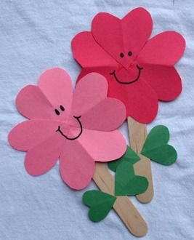  Make your own flowers: You will need lollipop sticks or straws, glue, scissors and colouring pencils. Draw your own flower OR use the template provided by scrolling down. Decorate the petals/flower head and leaves then cut them out.  Remember to always supervise your child when they use scissors.  Carefully glue and stick the petals/flower heads to the top of your lollipop stick or straw. Add the leaves. Once you have made as many flowers as you like you could put these in your own garden or deliver them safely as a gift. You may like to create a bouquet. If you would like to make your flower personal you can print a small photograph of yourself and stick it in the middle of the flower. We would love to see pictures of your flowers. Please send to updates@smfa.org.uk
20-30mins | Learning and play time | Spend time with your child as they choose their own toys to play with. Take the time to talk to them about their game and join in the play. Ask them what they are playing/making? How did they make it? What is it? How do you play? What makes it special? Ask them about their day and what they have enjoyed. Is there anything they would like to do again? What would they like to do tomorrow?  Spending quality time together is important and creates lots of memories for your child.
10-20 mins | Story time/Read a text  If you can’t find any books to read then you could make up your own stories together OR sing a nursery rhyme or favourite song

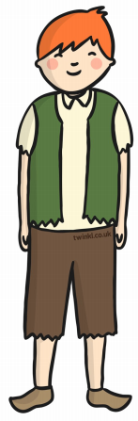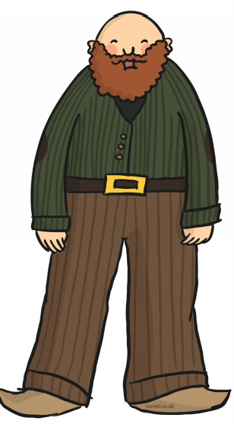

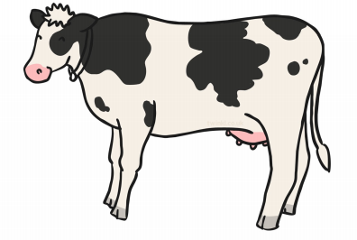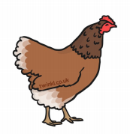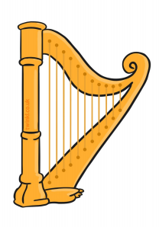

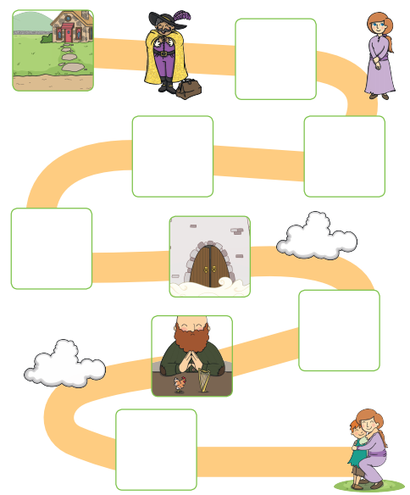
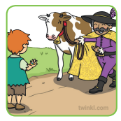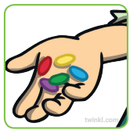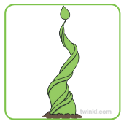
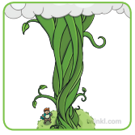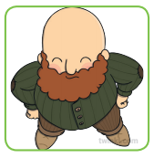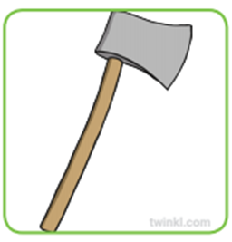

At the top of the beanstalk…
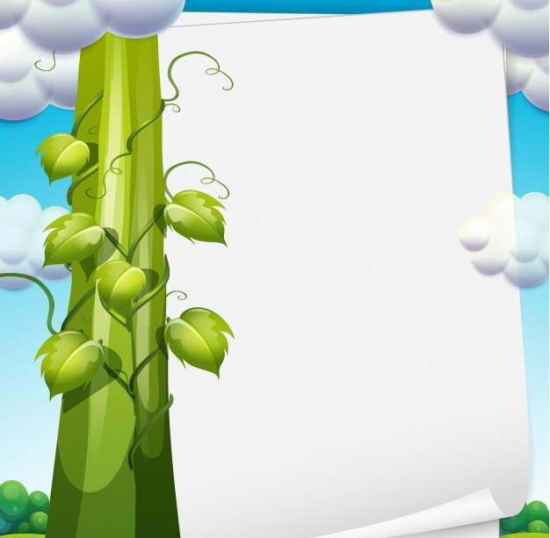

What does a plant need to grow?

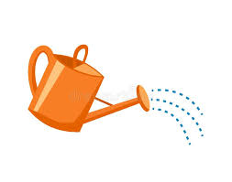

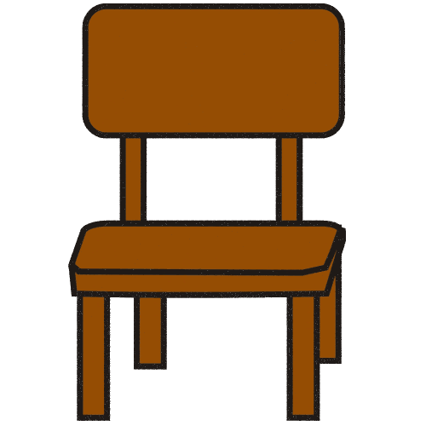
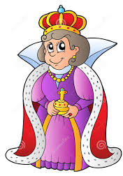

Finish the patterns
Common British Plants
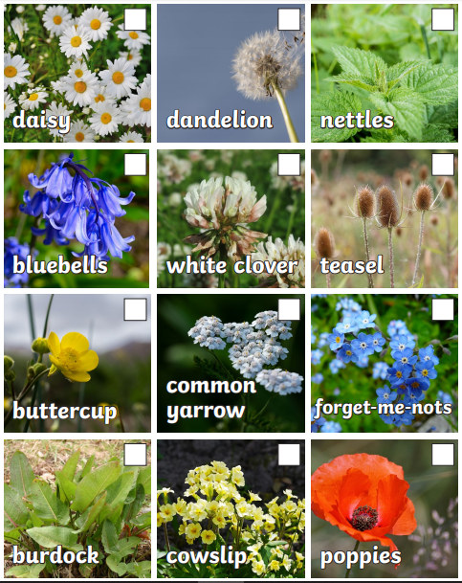

Parts of a flower

roots | leaf | flower | stem
