Monday
Approx. Timing | Suggested Activity | Activity Plan
10 mins | Mindfulness | This could be a colouring activity, a breathing exercise or a quiet handwriting exercise. Something that gets your child ready for a day of learning.
30 mins | PE with Joe Wicks /  Eat breakfast with family | This is where your child will have their bagels (if in school). It is a good time to do Joe Wicks PE! If you are at home or you could use this time to sit as a family and eat breakfast together. It is important to teach children how to hold a conversation or have good table manners.
30-40 mins | Reading Activity  Wash hands | Phonics activity  Watch and join in with set 1 sounds: https://www.youtube.com/watch?v=hCBzNnSSxds  Then set 2 and 3: https://www.youtube.com/watch?v=aR0BV1zaFDM  Today’s sound of the day is ‘EAR’ (Hear with your ear)  We are going to make our own elephant ears to wear. We are going to write lots of ‘EAR’ words around and in the ears.  You will need 3 pieces of paper two for the ears and one to make the headband. You need to cut two large ear shapes then stick them to a thin headband. You can then add a trunk using another piece of paper.  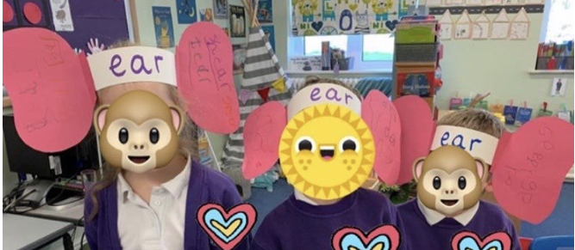  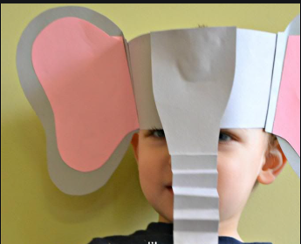  Ear Hear Tear Beard  Gear Fear Year Near  Pear Clear Dear Spear  Smear Rear
15-20 mins | Break Time
10 mins | Times tables Practice | You should practise times tables every day.  Reception: doubling and halving  Year 1&2: 2s, 5s, 10s  Year 3: 3s, 4s, 8s  Year 4,5,6: All timetables up to 12x12.
30-40 mins | Maths Activity | 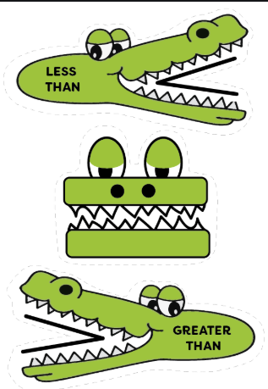  Starter Watch: https://www.youtube.com/watch?v=M6Efzu2slaI or https://www.youtube.com/watch?v=ka9zbPcqXBI  Today we are going to be looking at greater than, less than and equal to. You will need some toys and either make your own signs like the ones in the picture to the left. Or you can print the ones from this link: https://www.twinkl.co.uk/resource/t-n-649-greater-than-and-less-than-crocodiles  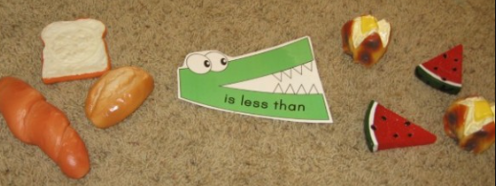  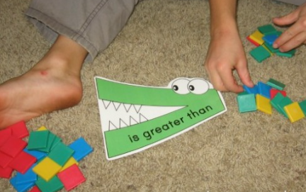  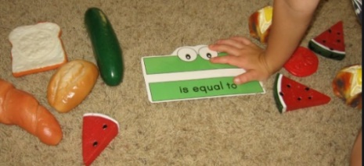  You will need to split your toys into two random piles. Now count each pile. Which one has the most toys in it? Which way should your crocodile face? Remember he always wants to eat the greatest number. Are they both the same? If the piles have the same number of toys in it, then what sign do you need? That’s right - you need the equals sign! I have attached some pictures of some examples.
30-40 mins | Lunch time
30-40 mins | Topic/English Activity | Everyday heroes and key workers. We will be looking at people who help us such as our keyworkers who we were clapping for every Thursday night.  Last week we looked at the people who help us. We looked at the people who help us: with our eyes, teeth and when we hurt ourselves. Then on Friday, we looked at people who help animals. Can you remember what they are called? That’s right, a veterinarian, or vet for short. Today we are going to focus on vets that work in zoos. Can you remember the Makaton sign for vet? Here it is to remind you: https://www.youtube.com/watch?v=VOSU_iRUEA8 . Can you see it is similar to doctor? That is because a vet is an animal doctor. In school we will look over a PowerPoint that talks through being a zoo vet. I have summarised the information from it below or here is a video that talks through being a zoo vet https://www.youtube.com/watch?v=z8ckAFRd5Eo .  Last Friday we looked at vets who work in vet surgeries but vets may also visit farms, zoos, parks or people’s homes in order to help the animal.  A zoo vet is a vet that works only in a zoo.  Zoo vets must be very careful because they sometimes work with dangerous and wild animals. What wild animal can you think of that you might see at the zoo which is dangerous? That’s right a lion, tiger, bear etc.  They help the other zoo workers to take care of the animals and make sure the animals are staying healthy.  They also work with people all over the world to find out more about wild animals and what special care they might need.  We are going to make our own zoo animal masks https://www.firstpalette.com/craft/printable-animal-masks.html . You can pick from the wild and zoo animals (bear, elephant, lion, monkey, panda, tiger etc.)  https://www.youtube.com/watch?v=7QNUoCvX9a8 Here is a video of a nice story about a zoo vet.
10 mins | Golden Mile/Physical Activity
30-40 mins | PSHE/Topic | Today’s emotion is being lonely.  Watch this video you need to start it at 12.49 https://www.youtube.com/watch?v=uvMx-roJxRw pause the video at 13.57 before it plays tomorrows emotion.  - How do you feel when you are lonely? Do you feel down, upset, like you have no one to talk to or play with? Maybe someone you love has gone away, you are on your own, feeling down, not much fun, missing someone etc.  - Which Inside Out character do you think represents being lonely? I would say Sadness as you tend to be down and upset. What colour is she? Blue. Do you think this is a good colour to represent loneliness? Yes or no? Why? If no, what colour should represent loneliness?  - Can you act out being lonely? Maybe your family could all act it out at once and then if you want to share you can.  - Now I want you to draw a lonely face. What does their face look like? Their eyes, mouth etc. You could paint, draw, use playdough or even use a tablet to draw on a doodle pad.  - Can you name a time you have felt lonely? Caregivers, you start by telling them a time you have felt lonely. Then it is the child’s turn. Discuss these experiences.  - What could we do to make ourselves feel better? You could tell yourself that it is okay, you could think of something positive to cheer you up, think of all the people who love you, think of all the good things you’ve done recently, do slow deep breathing to re-centre yourself etc.  https://www.youtube.com/watch?v=7w-dLSx7EYw Here is a story about being lonely.  https://www.getepic.com/sign-in/educator There is also a story on get epic about feeling lonely.
10-20 mins | Story time/Read a text
Tuesday
Approx. Timing | Suggested Activity | Activity Plan
10 mins | Mindfulness | This could be a colouring activity, a breathing exercise or a quiet handwriting exercise. Something that gets your child ready for a day of learning.
30 mins | PE with Joe Wicks /  Eat breakfast with family | This is where your child will have their bagels (if in school). it is a good time to do Joe Wicks PE if you are at home or you could use this time to sit as a family and eat breakfast together. It is important to teach children how to hold a conversation or have good table manners.
30-40 mins | Reading Activity  Wash hands | 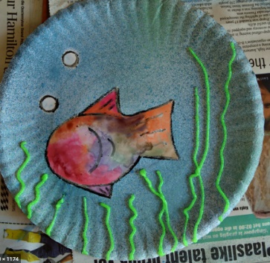  Phonics activity  Watch and join in with set 1 sounds: https://www.youtube.com/watch?v=hCBzNnSSxds  Then set 2 and 3: https://www.youtube.com/watch?v=aR0BV1zaFDM  Today’s sound of the day is ‘ea’ Cup of tea.  We are going to make a seascape picture and then write ‘ea’ words on it. We are going to look at what we would find under the sea: seaweed, jelly fish, fish, bubbles, coral and sand on the bottom of the ocean floor etc.  Tea Lead Leaf Read  Cream Beak Bean Peak  Speak Treat Team Pea  Sea Clean Seal Bead  Dream Seat Scream
15-20 mins | Break Time
10 mins | Times tables Practice | You should practise times tables every day.  Reception: doubling and halving  Year 1&2: 2s, 5s, 10s  Year 3: 3s, 4s, 8s  Year 4,5,6: All timetables up to 12x12.
30-40 mins | Maths Activity | Starter Watch: https://www.youtube.com/watch?v=M6Efzu2slaI or https://www.youtube.com/watch?v=ka9zbPcqXBI.  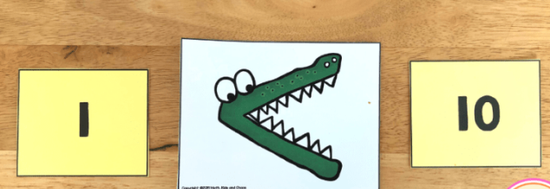  Today we are going to be consolidating our knowledge by using our crocodile signs from yesterday, but today we are going to be using number cards instead. You can either make number cards yourself or print them of from this link https://www.twinkl.co.uk/resource/t-n-373-number-digit-cards-0-50. I would begin with 1-20 then if they are finding this easy do 1-3, then 1-50 to really challenge them. You will need two numbers at a time and the children can pick these randomly. Once they have picked two numbers get them to place the right crocodile in place, so the example below is showing 1 is less than 10. The crocodile is facing the larger number. This link shows you some examples of activities to do using your crocodile cards.  https://www.mathkidsandchaos.com/comparing-numbers-kindergarten/
30-40 mins | Lunch time
30-40 mins | Topic/English Activity | Everyday heroes and key workers. We will be looking at people who help us such as our keyworkers who we were clapping for every Thursday night.  Yesterday we looked at people who help animals, can you remember what they are called? That’s right a veterinarian or vet for short. We looked at vets that work in zoos and today we are going to look at veterinarian nurses. Can you remember the Makaton sign for vet? Here it is to remind you https://www.youtube.com/watch?v=VOSU_iRUEA8 can you see it is similar to doctor that is because a vet is an animal doctor.  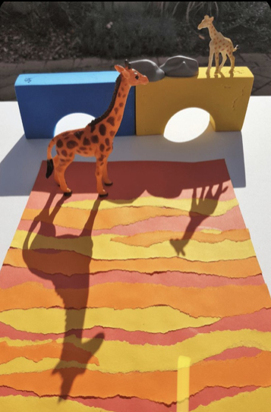  In school we will look over a PowerPoint that talks through being a zoo veterinarian nurse I have summarised the information from it below or here is a video that talks though being a zoo vet https://www.youtube.com/watch?v=z8ckAFRd5Eo .  A veterinary nurse is someone who helps a vet. Like the vet, they also look after poorly or injured animals.  A veterinary nurse also does lots of different things. These include:  - looking after animals that are being kept at the vet’s surgery  - feeding and walking animals  - doing tests on animals to check what is wrong  - helping the vet with operations  - teaching people how to look after their animals  - giving medicine to poorly animals  Today our activity is to make a sunset shadow picture. You will need: an A4 piece of paper, coloured paper (red, orange and yellow), a pencil, toy (preferably a wild animal) and sunlight to create your shadow.  First, you need to tear strips of the coloured paper and stick them down, so they overlap. Next you need to place you animals in front of your paper, so the shadow is cast over the coloured paper. Now draw round the shadow of your wild animal. There is a picture above that shows an example.
10 mins | Golden Mile/Physical Activity
30-40 mins | PSHE/Topic | Today’s emotion is nervous.  Watch this video you need to start it at 14.00 https://www.youtube.com/watch?v=uvMx-roJxRw pause the video at 15.04 before it plays tomorrows emotion.  - How do you feel when you are nervous? Maybe you feel a little bit worried, anxious, scared, not wanting to try something new due to feeling unsure and uneasy, funny feeling in your tummy, mouth goes dry, butterflies in your tummy, worried about mistakes etc.  - Which Inside Out character do you think represents being nervous? I would say fear as you tend to feel worried, anxious and a little bit scared. What colour is he? Purple, do you think this is a good colour to represent feeling nervous? Yes or no? Why? If no, what colour should represent feeling nervous?  - Can you act out being nervous? Maybe your family could all act it out at once and then if you want to share you can.  - Now I want you to draw a nervous face, what does their face look like? Think about their eyes, mouth etc. You could: paint, draw, use playdough or even use a tablet to draw on a doodle pad.  - Can you name a time you have felt nervous? Caregivers you start by telling them a time you have been nervous now it the child’s turn. Discuss these experiences.  - What could we do to make ourselves feel better? Tell ourselves that it is okay, practice makes perfect, we all must try something new from time to time, you could think of something positive to cheer you up, do slow deep breathing to re-centre yourself etc.  Here is a video including the Makaton for nervous https://www.youtube.com/watch?v=n8c1pyxJGxk here is a story about a nervous turtle https://www.youtube.com/watch?v=f68sJ6klmSs .
10-20 mins | Story time/Read a text
Wednesday
Approx. Timing | Suggested Activity | Activity Plan
10 mins | Mindfulness | This could be a colouring activity, a breathing exercise or a quiet handwriting exercise. Something that gets your child ready for a day of learning.
30 mins | PE with Joe Wicks /  Eat breakfast with family | This is where your child will have their bagels (if in school) it is a good time to do Joe Wicks PE if you are at home or you could use this time to sit as a family and eat breakfast together. It is important to teach children how to hold a conversation or have good table manners.
30-40 mins | Reading Activity  Wash hands | 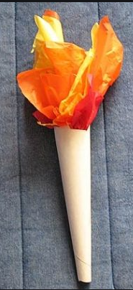  Phonics activity  Watch and join in with set 1 sounds: https://www.youtube.com/watch?v=hCBzNnSSxds  Then set 2 and 3: https://www.youtube.com/watch?v=aR0BV1zaFDM  Today’s sound of the day is ‘or’ Shut the door.  Can you think of lots of words with the sound ‘or’ in maybe write them all down in a picture of a door or maybe you could make a torch? Can you decorate your work and colour it in? Here is a link on how to make a torch. You will need paper and pens to decorate it, tissue paper (red, yellow and orange) and tape or glue. https://alittlepinchofperfect.com/easy-kid-craft-paper-party-horns/  Door Horn Fork Doctor  North Torch Floor Sport  Port Short Cork Corn  Word Cord Porch Torn
15-20 mins | Break Time
10 mins | Times tables Practice | You should practise times tables every day.  Reception: doubling and halving  Year 1&2: 2s, 5s, 10s  Year 3: 3s, 4s, 8s  Year 4,5,6: All timetables up to 12x12.
30-40 mins | Maths Activity | Starter Watch: https://www.youtube.com/watch?v=M6Efzu2slaI or https://www.youtube.com/watch?v=ka9zbPcqXBI  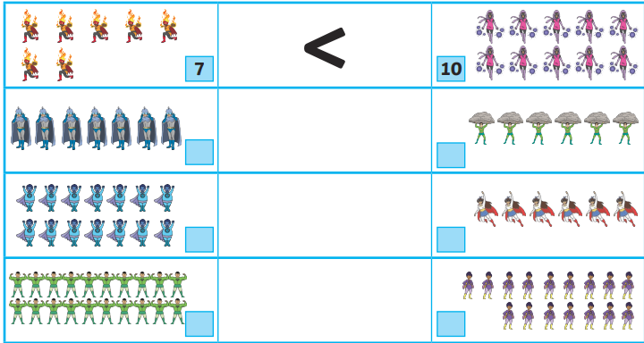  Today we are going to be putting what we have learnt practically to the test and completing a worksheet that uses pictures instead of numbers. I have attached a link for one that you can print for free and a picture, so you can see what it is like if you would like to make your own. First get your child to count the pictures and write the number in the box. Then once they have done this get them to compare the numbers and draw the correct symbol ether <, > or =.  https://www.tes.com/teaching-resource/more-than-less-than-and-equals-worksheet-year-1-11992762
30-40 mins | Lunch time
30-40 mins | Topic/English Activity | Everyday heroes and key workers. We will be looking at people who help us such as our keyworkers who we were clapping for every Thursday night.  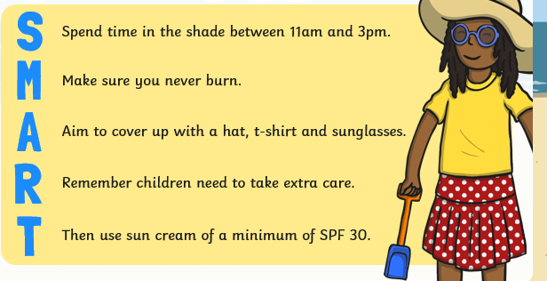  Yesterday we spoke about veterinarian nurses who help look after animals. Today we are going to look at people who help us when we get into trouble when swimming in water. So, if we are swimming in the sea or at the pool and we get into trouble who would help us? Do you know what they are called? That’s right a lifeguard!  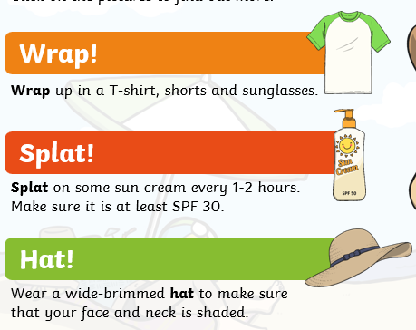  Here is the Makaton sign for swimming: https://www.youtube.com/watch?v=4ivLVam5V38 and the Makaton sign for safe as when we are swimming we need to stay safe and the lifeguards help us to stay safe https://www.youtube.com/watch?v=fAg5hk55ROg  In school we are going through a PowerPoint about staying safe at the beach and in the sun. I will make notes about points you can talk to your child about:  It’s easy to get sunburnt, even when you’re not expecting to. Spending too much time in the sun can be harmful. You can still burn on a cloudy day! Young skin is very delicate and is easily damaged by the sun.  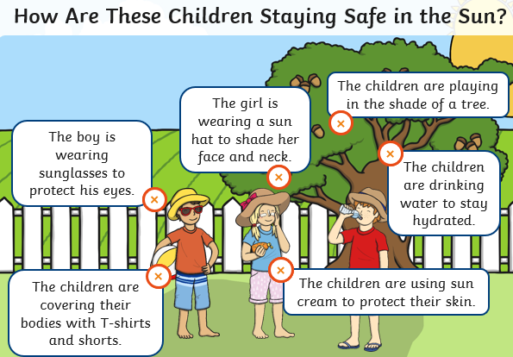  What can we do to protect ourselves? We could: wear a sun hat, glasses, sun cream, drinking lots of water, sitting in the shade and covering up by having a top and shorts/skirt on. Think about the SMART anagram as sown in the picture and the wrap, splat and hat rhyme. These will help you to remember to stay safe in the sun and at the beach.  Just swim where it’s safe to – preferably at a lifeguard patrolled beach. Make sure you can swim, never swim alone and make sure you are always supervised by an adult at the beach. Keep an eye on the weather – if it’s very windy or the sea is rough, do not swim or use inflatables in the sea.  Here are two videos that help explain what a lifeguard does.  https://www.youtube.com/watch?v=XIxmo3zp6lE or https://www.youtube.com/watch?v=Fw61y2EwgzE  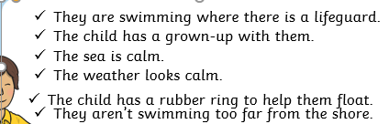  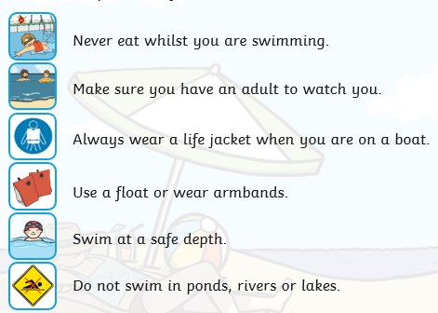  https://cefnmawr-pri.wrexham.sch.uk/wp-content/uploads/2020/06/06-sun-sea-and-beach-safety-cut-out-activity.pdf Here is a link to an activity where you make puppets wearing the right protection from the sun.
10 mins | Golden Mile/Physical Activity
30-40 mins | PSHE/Topic | Today’s emotion is envious.  Watch this video you need to start it at 15.05 https://www.youtube.com/watch?v=uvMx-roJxRw pause the video at 16.10 before it plays tomorrows emotion.  - How do you feel when you are envious? Do you feel like your tummy is in a not, do you ever want something that someone else has got, do you ever feel like someone is better than you or got more than you, remember we can’t have everything.  - Which Inside Out character do you think represents being envious? I would say maybe angry as you tend to feel a bit annoyed and jealous. What colour is he? Red, do you think this is a good colour to represent being envious. Yes or no? Why? If no, what colour should represent feeling envious? Maybe sadness would work too for envious as you tend to feel a bit down and upset when you are envious.  - Can you act out being envious? Maybe your family could all act it out at once and then if you want to share you can.  - Now I want you to draw an envious face what does their face look like? Their eyes, mouth etc. You could paint, draw, use playdough or even use a tablet to draw on a doodle pad.  - Can you name a time you have been envious? Caregivers you start by telling them a time you have been envious now it the child’s turn. Discuss these experiences.  - What could we do to make ourselves feel better? We should feel happy for our friends, remember we are all good at different things, tell them well done if they beat you in a race or did something well, maybe next time you will win it is good to learn how to be a good sportsman, remember we can’t have everything. You could think of something positive to cheer you up, do slow deep breathing to re-centre yourself.  Here is an explanation about being jealous/envious https://www.youtube.com/watch?v=fLvvZTWHreY
10-20 mins | Story time/Read a text
Thursday
Approx. Timing | Suggested Activity | Activity Plan
10 mins | Mindfulness | This could be a colouring activity, a breathing exercise or a quiet handwriting exercise. Something that gets your child ready for a day of learning.
30 mins | PE with Joe Wicks /  Eat breakfast with family | This is where your child will have their bagels (if in school) it is a good time to do Joe Wicks PE if you are at home or you could use this time to sit as a family and eat breakfast together. It is important to teach children how to hold a conversation or have good table manners.
30-40 mins | Reading Activity  Wash hands | Phonics activity  Watch and join in with set 1 sounds: https://www.youtube.com/watch?v=hCBzNnSSxds  Then set 2 and 3: https://www.youtube.com/watch?v=aR0BV1zaFDM  Today’s sound of the day is ‘air’ That’s not fair  Today we are going to make an airplane and write our ‘air’ words on them.  You will need a large piece of plain paper to fold to make a paper airplane to then write your ‘air’ words on. After folding your plane then get your child to write their words on strips of paper and then attached the strips of paper to the back of the plane so they dangle off the back. Once you have done this you can colour in your plane.  https://www.youtube.com/watch?v=1PVA2nPU60U here is a video of how to fold a paper plane.  Fair Stair Pair Éclair  Hair Repair Chair Airship  Unfair Hairbrush Lair Airport
15-20 mins | Break Time
10 mins | Times tables Practice | You should practise times tables every day.  Reception: doubling and halving  Year 1&2: 2s, 5s, 10s  Year 3: 3s, 4s, 8s  Year 4,5,6: All timetables up to 12x12.
30-40 mins | Maths Activity | Starter Watch: https://www.youtube.com/watch?v=M6Efzu2slaI or https://www.youtube.com/watch?v=ka9zbPcqXBI  Today we are going to be putting what we have learnt practically to the test and completing a worksheet that uses numbers only today, instead of yesterday’s one that had pictures. I have attached a link for one that you can print for free and a picture so you can see what it is like if you would like to make your own. Get them to compare the numbers and draw the correct symbol ether <, > or =.  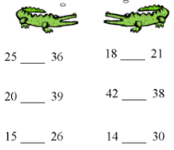  https://www.tes.com/teaching-resource/greater-than-less-than-crocodiles-6412347  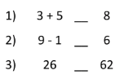  To increase the difficulty, you can use sums on one side and numbers on the other or even two sums. They would have to first work out the sum, write the answer then compare the answers using their greater than, less than or equal to.
30-40 mins | Lunch time
30-40 mins | Topic/English Activity | Everyday heroes and key workers. We will be looking at people who help us such as our keyworkers who we were clapping for every Thursday night.  Yesterday we spoke about people who help us when we get into trouble when swimming in water. So, if we are swimming in the sea or at the pool and we get into trouble who would help us? Can you remember what they are called? That’s right a lifeguard!  Can you remember the acronym we used yesterday to remind ourselves to stay protected SMART and then we also had our rhyme can you remember it? Wrap, splat and hat!  Today we are going to look at the other heroes who help us if we get into trouble when out on a boat or in the water. They are the RNLI. This stands for Royal National Lifeboat Institution. Here is a nice video talking through the RNLI https://www.youtube.com/watch?v=nO1uRoqXxd4. Here are some facts about the RNLI: https://www.bbc.co.uk/newsround/19850597 . In class we are going through a PowerPoint the main points are:  - RNLI is a charity that saves people lives at sea  - 24 hour service  - Most RNLI lifeboat crew are volunteers give up their own time and don’t get paid  - Lifeboat crew kid includes items such as gloves, boots, waterproofs, thermal under suit and top dry suit, life jacket and helmet  - There are 237 lifeboat stations around the UK and Republic of Ireland  - There are four lifeboat stations along the River Thames  - RNLI lifeguards patrol over 200 beaches around the UK and Channel Islands  - The RNLI has a flood rescue team  - It costs about £460,000 to run the RNLI every day  - There are around 4,600 RNLI volunteers in the UK  - The RNLI rescues an average of 23 people every day  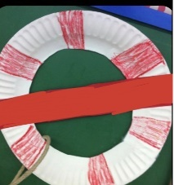  Our activity for today is that we are going to make our own life ring/preserver using a paper plate cut a hole out the middle and then colour in red stripes around the edges. I have attached a picture of an example on the red strip of paper you can write RNLI.  Another option is using string like in this video:  https://www.youtube.com/watch?v=pBFQThp01uM .
10 mins | Golden Mile/Physical Activity
30-40 mins | PSHE/Topic | Today’s emotion is kind.  Watch this video you need to start it at 16.11 https://www.youtube.com/watch?v=uvMx-roJxRw pause the video at 17.24 before it plays tomorrows emotion.  - How do you feel when you are kind?  - Which Inside Out character do you think represents being kind? I would say maybe joy as you tend to feel happy and good especially after you have been kind to your friends or done a kind act. What colour is joy? Yellow, do you think this is a good colour to represent being kind. If yes, why if no what colour do you think she represent kindness?  - Can you act out being kind? Maybe your family could all act it out at once and then if you want to share you can.  - Now I want you to do something kind maybe you could make a family member a drink or get them a snack, you could help your parents by doing some chores like washing up, putting washing in washing machine etc.  - Can you name a time you have been kind? Caregivers you start by telling them a time you have been kind now it the child’s turn. Discuss these experiences.  https://www.youtube.com/watch?v=MTu_60rCHBw this is the Makaton sign for being kind. Here is a short video about being kind https://www.youtube.com/watch?v=8Wi0UWLeT9I .
10-20 mins | Story time/Read a text
Friday
Approx. Timing | Suggested Activity | Activity Plan
10 mins | Mindfulness | This could be a colouring activity, a breathing exercise or a quiet handwriting exercise. Something that gets your child ready for a day of learning.
30 mins | PE with Joe Wicks /  Eat breakfast with family | This is where your child will have their bagels (if in school) it is a good time to do Joe Wicks PE if you are at home or you could use this time to sit as a family and eat breakfast together. It is important to teach children how to hold a conversation or have good table manners.
30-40 mins | Reading Activity  Wash hands | Phonics activity  Watch and join in with set 1 sounds: https://www.youtube.com/watch?v=hCBzNnSSxds  Then set 2 and 3: https://www.youtube.com/watch?v=aR0BV1zaFDM  Today’s sound of the day is ‘ow’ Brown cow.  Today we are going to draw a picture of an owl and then write ‘ow’ words around it or inside it. You could make a crown to wear on your head with the words on it.  You will need a large piece of plain paper to trace your picture on, or print out the template from the link below or free hand draw an owl. Now write as many ‘ow’ words as you can think of around your picture or inside the owl. You can write them in different colours is you want to. Once you have written the words you can decorate your picture.  http://www.supercoloring.com/coloring-pages/owl-3 here is a printable colouring sheet.  Brown Cow Now Down  Owl How Bow Pow  Row Town Brown Clown  Crown Crowd Gown Wow
15-20 mins | Break Time
10 mins | Times tables Practice | You should practise times tables every day.  Reception: doubling and halving  Year 1&2: 2s, 5s, 10s  Year 3: 3s, 4s, 8s  Year 4,5,6: All timetables up to 12x12.
30-40 mins | Maths Activity | Starter watch: https://www.youtube.com/watch?v=THYIzpMOV-M and https://www.youtube.com/watch?v=c-vAOjeCUTI  Today we are going to remind ourselves about subtraction/take away. We are going to be using a number line to 30 to assist us.  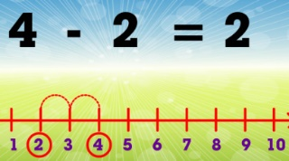  https://www.tes.com/teaching-resource/subtraction-using-a-number-line-6316663 Here is a link to a work sheet that has a number line along with subtraction questions. The second video in the starter helps show you how to use your number line to assist you to answer the questions. So first look at the first number in the questions e.g. 10-5= so 10 is the first number find this on your number line circle it. We are subtracting/taking away so that means we need to take jumps backwards to make our number smaller. So now the second number tells us how many jumps back we need to do, so 5 for the above question. So, if we jump back 5 on our number line by drawing lines as shown in the picture, what number do we land on? 5, so the answer to 10-5=5.
30-40 mins | Lunch time
30-40 mins | Topic/English Activity | Everyday heroes and key workers. We will be looking at people who help us such as our keyworkers who we were clapping for every Thursday night.  Yesterday we spoke about people who help us when we get into trouble when on the water. Do you know what they are called? That’s right a RNLI Royal National Lifeboat Institution! Today we are going to look at the people who help us if there is a fire. What are they called? Firefighters that’s right.  Here is Makaton for firefighter https://www.youtube.com/watch?v=77dXusyi6gg .  We are going to be looking at a PowerPoint these are the main points:  - They keep everyone safe by putting out fires  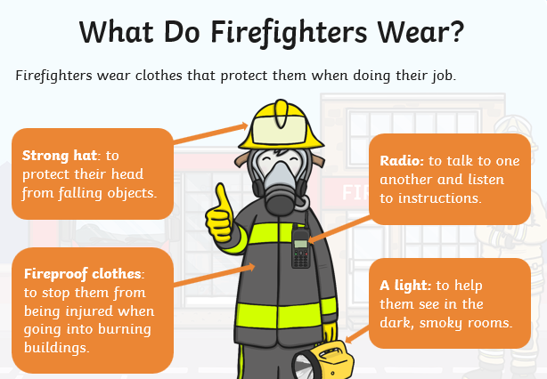  - They use their equipment to help rescue people who are trapped  - They work long hours in the day and night  - What do you think great firefighters need to be? Here is a list of examples: brave, strong, healthy, hardworking, reliable, trustworthy, determined etc  - Firefighters work in a fire station. Fire stations are all around the country  - Firefighters travel in their fire engines  - Fire engines are red. The fire engine has flashing lights that are red and blue  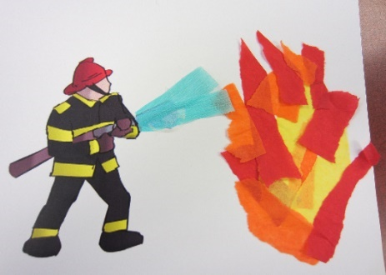  - What do they wear? Look at the picture to see if you are right.  This video talks about firefighters and fire engines https://www.youtube.com/watch?v=CjbC9wAErts and this is a Makaton song about 5 little firemen https://www.youtube.com/watch?v=x_I2ysM0w0g .  The activity today is making a tissue paper fire using red, yellow and orange tissue paper. Then stick a fire man holding a hose down. Then add blue tissue paper water to put the fire out. I have attached an example in the picture beside.  Here is a nice book to share together https://www.youtube.com/watch?v=tf_ZD-1XykE .
10 mins | Golden Mile/Physical Activity
30-40 mins | PSHE/Topic | Today’s emotion is grumpy.  Watch this video you need to start it at 17.27 https://www.youtube.com/watch?v=uvMx-roJxRw pause the video at 18.33 before it plays tomorrows emotion.  - How do you feel when you are grumpy? Annoyed, stompy, moody, wanting to be on your own, getting annoyed by every little thing, huffy and puffy, wanting to shout etc.  - Which Inside Out character do you think represents being grumpy? I would say maybe angry as you tend to feel a bit annoyed and stompy. What colour is he? Red do you think this is a good colour to represent being grumpy. Yes or no? why? If no, what colour should represent feeling grumpy?  - Can you act out being grumpy? Maybe your family could all act it out at once and then if you want to share you can.  - Now I want you to draw a grumpy face what does their face look like? Their eyes, mouth etc. You could paint, draw, use playdough or even use a tablet to draw on a doodle pad.  - Can you name a time you have been grumpy? Caregivers you start by telling them a time you have been grumpy now it the child’s turn. Discuss these experiences.  - What could we do to make ourselves feel better? Take a nap, you could think of something positive to cheer you up, do slow deep breathing to re-centre yourself.  Here is a story about a grumpy monkey https://www.youtube.com/watch?v=wylzbbSL668 and here is a story with Makaton narration about Mr Gumpy’s outing https://www.youtube.com/watch?v=uQmOuL64D_E .
10-20 mins | Story time/Read a text

