Monday
Approx. Timing | Suggested Activity | Activity Plan
10 mins | Mindfulness | This could be a colouring activity, a breathing exercise or a quiet handwriting exercise. Something that gets your child ready for a day of learning.
30 mins | PE with Joe Wicks /  Eat breakfast with family | This is where your child will have their bagels (if in school) it is a good time to do Joe Wicks PE if you are at home or you could use this time to sit as a family and eat breakfast together. It is important to teach children how to hold a conversation or have good table manners.
30-40 mins | Reading Activity  Wash hands | Black Death  - Talk to an adult about the text. Explain the subject what it is about), purpose (why it has been written), audience (who would read it) and text type (what type of text it is).  - Identify the character in the text. Do you think they are real or fictional? Explain your answer.  - Identify when it was written – talk to an adult about things that would be different when the text was set.
15-20 mins | Break Time
10 mins | Times tables Practice | You should practise times tables every day.  Year 4,5,6: All timetables up to 12x12.  Timestables Rockstars/Timestables games in class  Complete the multiplication grid .
30-40 mins | Maths Activity  Drawing lines accurately | Mental arithmetic skills:  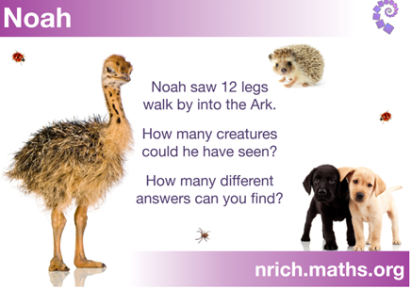  Is there more than one answer?  Think about how we can work systematically.  How can I prove that I have every combination of creatures?  Write a Point, Evidence and explain answer. You can draw and write a calculation to prove your answer.  Use the same method for: Make 37.  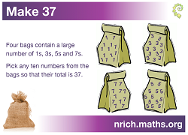
30-40 mins | Lunch time
30-40 mins | Topic/English Activity | The Plague  https://www.youtube.com/watch?v=LBvOZO1gmOE  Watch the clips. Make notes about the plague. Think about what life was like in London at that time.  Use the resource named Activity One (P.2) to compare London in 1660’s and now.
10 mins | Golden Mile/Physical Activity
30-40 mins | PSHE/Topic | Transition unit  Activity: My strengths and talents.  Look at my strength and talents in this week’s resources (P5). Think about what makes you- you. Speak to people at home and see what they think of your strengths. Do they agree? Do they think you have different talents? Use the sheet to record your own thoughts. You can send them in to school, we would love to see them.
10-20 mins | Story time/Read a text and watch Newsround with an adult.
Tuesday
Approx. Timing | Suggested Activity | Activity Plan
10 mins | Mindfulness | This could be a colouring activity, a breathing exercise or a quiet handwriting exercise. Something that gets your child ready for a day of learning.
30 mins | PE with Joe Wicks /  Eat breakfast with family | This is where your child will have their bagels (if in school) it is a good time to do Joe Wicks PE if you are at home or you could use this time to sit as a family and eat breakfast together. It is important to teach children how to hold a conversation or have good table manners.
30-40 mins | Reading Activity  Wash hands | Re-read Black Death  1.Underline any words you are not sure of. Ask an adult to help you understand the meaning.  2. Discuss which texts you would expect to see a glossary in. What is the purpose of a glossary?  3. Use your detective skills to predict what these words mean. Find them in the text and read the sentence. If you are not sure, try and replace the unknown word with another word in the sentence and check to see if it still makes sense.  Word Definition Sentence Synonym  Anxious  Dread  Desolate  Relief  Choose one word and complete the Vocabulary Laboratory on P.6 of the resources. Ask an adult to help. You can look up meanings, word classes, synonyms and antonyms in a dictionary or ask an adult to help.
15-20 mins | Break Time
10 mins | Times tables Practice | You should practise times tables every day  Timestables Rockstars/Timestables games in class.  Complete the multiplication grid.
30-40 mins | Maths Activity | Deca tree  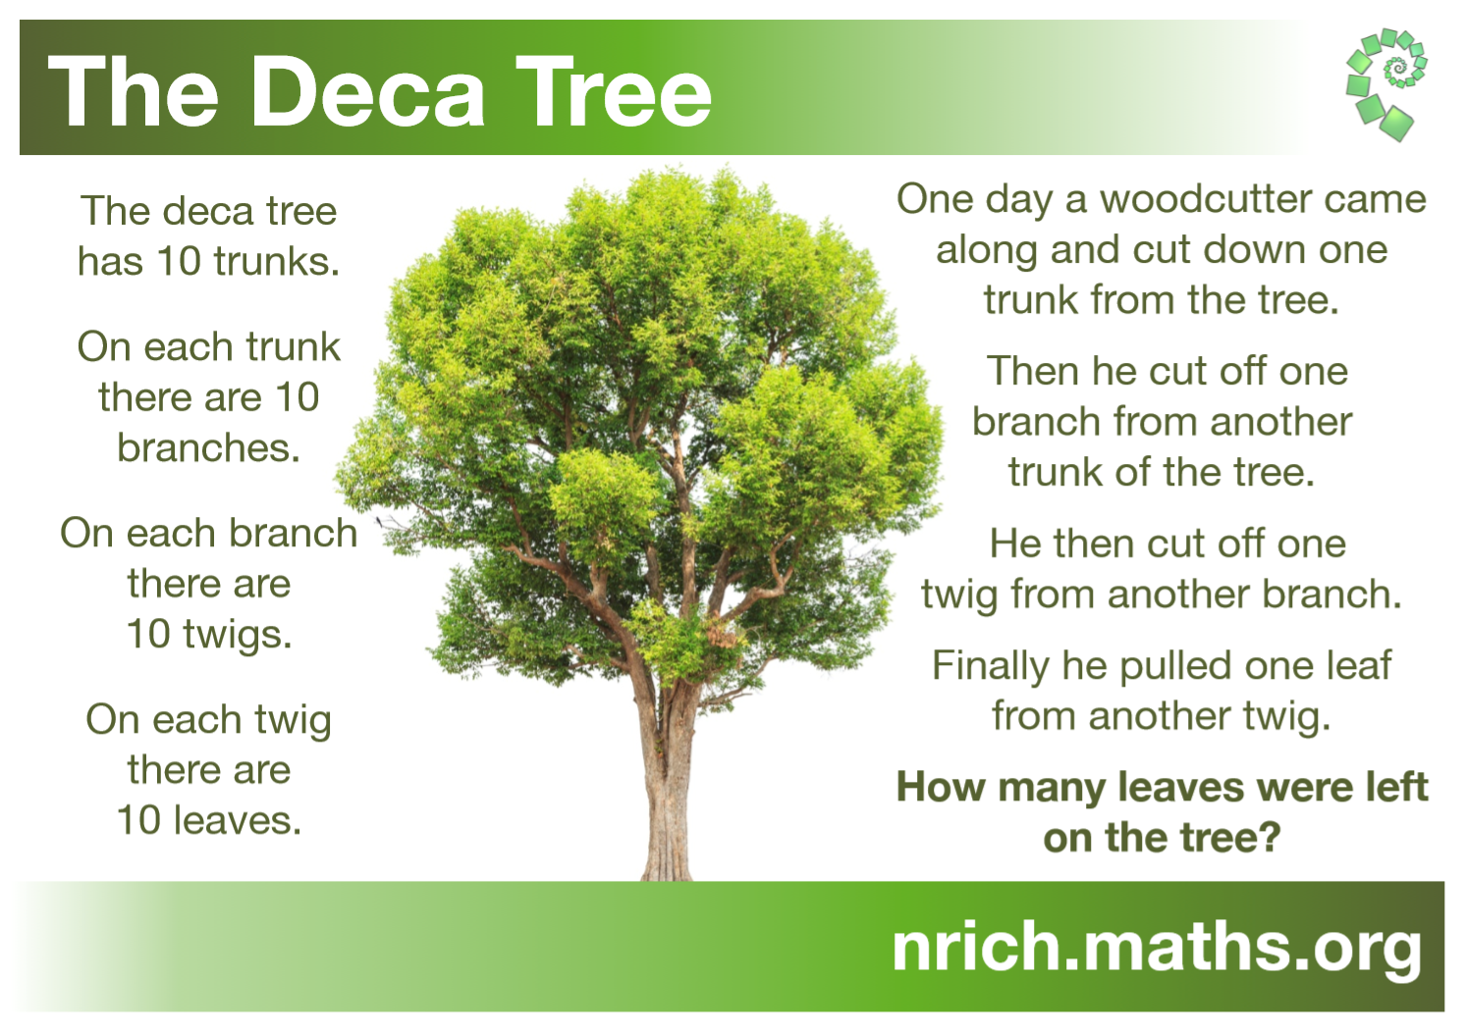  Draw the Deca Tree to help you visualise the problem. Ask an adult to help you. Once you have solved the problem write a calculation to prove it.  Reflect on how you solved the problem. What maths facts helped you to calculate?
30-40 mins | Lunch time
30-40 mins | Topic/English Activity | Ring of Roses.  https://www.youtube.com/watch?v=LBvOZO1gmOE  Watch Horrible Histories  Look at the KS2 Great Plague Information sheets (P3-4) Use the diagram on (P7) or create your own to show the symptoms of the plague.
10 mins | Golden Mile/Physical Activity
30-40 mins | PSHE/Topic | PSHE:  Complete the ‘I am Pound of’ sheet (P.8). Think about things in school and out of school that you have achieved. It could be things like taking part in a football match, helping a friend or learning to use the washing machine. Complete the sheet and decorate it. Display it in your house and remember how amazing you are.
10-20 mins | Story time/Read a text Holes
Wednesday
Approx. Timing | Suggested Activity | Activity Plan
10 mins | Mindfulness | This could be a colouring activity, a breathing exercise or a quiet handwriting exercise. Something that gets your child ready for a day of learning.
30 mins | PE with Joe Wicks /  Eat breakfast with family | This is where your child will have their bagels (if in school) it is a good time to do Joe Wicks P.E if you are at home or you could use this time to sit as a family and eat breakfast together. It is important to teach children how to hold a conversation or have good table manners.
30-40 mins | Reading Activity  Wash hands | Re-read the Black Death diary entry. Pages 9-10 of the resources pack.  Answer questions: 1-7
15-20 mins | Break Time
10 mins | Times tables Practice | You should practise times tables every day.  Year 4,5,6: All timetables up to 12x12.  Timestables Rockstars/Timestables games in class  Complete the multiplication square – ‘dice’ on P1 or the resources document.
30-40 mins | Maths Activity | Recognising and reading co-ordinates. Page 11 of the resources pack.  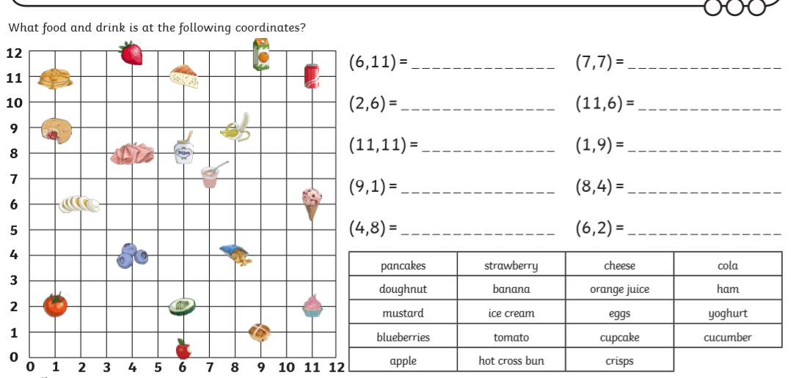
30-40 mins | Lunch time
30-40 mins | Topic/English Activity | Watch the clip:  Talk to an adult about what you have watched. Discuss how the plague was spread and what people did to stop the plague spreading.  Complete activity 2 in the resources pack (P.12). You can draw your own pictures and write a short explanation of how the plague spread.
10 mins | Golden Mile/Physical Activity
30-40 mins | PSHE/Topic | Complete: My favourite year at primary school on page 13 of the resource pack. Think about what made your favourite year so special? Who you were friends with? And what you learnt that made it an amazing year. Decorate the sheet and display it so you can focus on positive memories.
10-20 mins | Story time/Read a text
Thursday
Approx. Timing | Suggested Activity | Activity Plan
10 mins | Mindfulness | This could be a colouring activity, a breathing exercise or a quiet handwriting exercise. Something that gets your child ready for a day of learning.  Mindfulness
30 mins | PE with Joe Wicks /  Eat breakfast with family | This is where your child will have their bagels (if in school) it is a good time to do Joe Wicks PE if you are at home or you could use this time to sit as a family and eat breakfast together. It is important to teach children how to hold a conversation or have good table manners.
30-40 mins | Reading Activity  Wash hands | Look at the diary entry (The Black Death). Using your amazing knowledge can you write a diary extract as if you were living during the plague.
15-20 mins | Break Time
10 mins | Times tables Practice | You should practise times tables every day.  Year 4,5,6: All h up to 12x12.  Timestables Rockstars/Timestables games in class.
30-40 mins | Maths Activity | 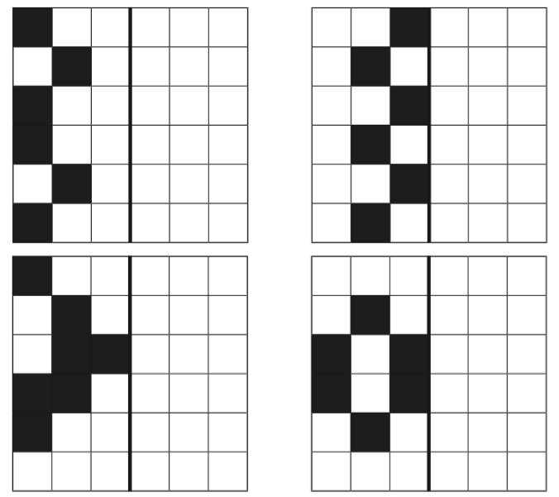  Use the reflection sheet in your resources pack (P.13)  Reflect the patterns.  Challenge yourself to make an optical art inspired reflection.
30-40 mins | Lunch time
30-40 mins | Topic/English Activity | Thursday  What help was available?  Watch the clip: https://www.bbc.co.uk/bitesize/guides/zd3wxnb/video  Label the Plague doctor (P14-15 of the resource pack). Explain why the doctors’ uniform was designed.  Challenge: complete the advert for a new plague doctor. Think about what qualities you would want in a plague doctor,
10 mins | Golden Mile/Physical Activity
30-40 mins | PSHE/Topic | PSHE: Goals for the future (P.16 of the resource pack)  Think about all the things you have achieved from when you were little. Discuss what you like to do at home and in school with an adult. Now think about the things you want to do next year, when you are 16 and when you are an adult. What things really stand out? These are the things that you aspire to do. They are your goals – share them with your family and use the Goals for the Future sheet to record them.
10-20 mins | Story time/Read a text
Friday
Approx. Timing | Suggested Activity | Activity Plan
10 mins | Mindfulness | This could be a colouring activity, a breathing exercise or a quiet handwriting exercise. Something that gets your child ready for a day of learning.  Mindfulness flower colouring
30 mins | PE with Joe Wicks /  Eat breakfast with family | This is where your child will have their bagels (if in school) it is a good time to do Joe Wicks PE if you are at home or you could use this time to sit as a family and eat breakfast together. It is important to teach children how to hold a conversation or have good table manners.
30-40 mins | Reading Activity  Wash hands | Quick Reads  Read: Water Safety in Open Water (P.17 of the resource pack)  Use the numbers at the side of the text to time how long it takes you to read.  Answer the question then check your answers with an adult.
15-20 mins | Break Time
10 mins | Times tables Practice | You should practise times tables every day.  Year 4,5,6: All timetables up to 12x12.  Timestables Rockstars/Timestables games in class. Complete ‘drone’ on P1 or the resources document.
30-40 mins | Maths Activity | Translation  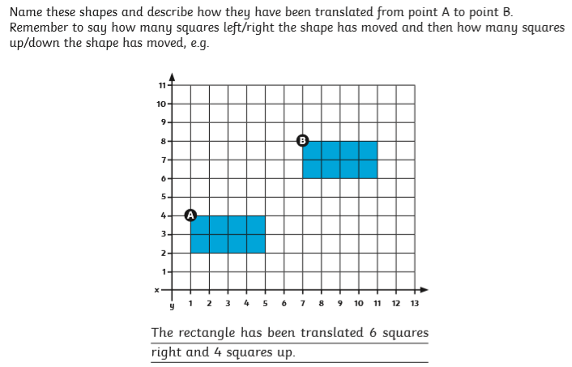  Remember the size and orientation of the shape does not change but the position does. Use this to help you complete the challenges on page 18 of your resource pack.
30-40 mins | Lunch time
30-40 mins | Topic/English Activity | Friday:  Use all the information you have gathered about The Black Death and make your own information text. Use titles, subtitles, diagrams and images to structure your text. Think about the topics of each paragraph or section of your text and make sure to include a introduction and conclusion.
10 mins | Golden Mile/Physical Activity
30-40 mins | PSHE/Topic | Complete the comic strip of my most exciting moments. You can use this to record memories in or out of school that are important to you. You can find the comic strip on page 19 of your resource pack.
10-20 mins | Story time/Read a text

