Monday
Approx. Timing | Suggested Activity | Activity Plan
10 mins | Mindfulness | This could be a colouring activity, a breathing exercise or a quiet handwriting exercise. Something that gets your child ready for a day of learning.
30 mins | PE with Joe Wicks or dance online/  Eat breakfast with family | This is where your child will have their bagels (if in school) it is a good time to do Joe Wicks PE if you are at home or you could use this time to sit as a family and eat breakfast together. It is important to teach children how to hold a conversation or have good table manners. We have been dancing in class https://www.youtube.com/watch?v=FP0wgVhUC9w https://www.youtube.com/watch?v=C_el3h46_kQ  https://www.youtube.com/watch?v=leMaOZOX6_k https://www.youtube.com/watch?v=IZKO16VOgLs  https://www.youtube.com/watch?v=VNhiGx4xLhA
30-40 mins | RWI  ou shout it out  ow brown cow  Wash hands | https://www.youtube.com/watch?v=07YNCFlS0iI hand washing song  Quick dash of sounds already know look at sound sheet. Remember the ou ow sounds (look at sheet at end of planning for all the ways to spell the ou ow sounds) and sound out some words with that sound in and let your child blend the word (e.g. shout you sound out sh-ou-t and your child says shout / brown you sound out b-r-ow-n and your child says brown) repeat with 3 more words ou (cloud, out, proud, lout) ow (now, bow, town, crown) and then practise writing the ou ow sounds. Fred talk (sound out with your child) 3 or 4 words with the ou ow sounds in them. Spell some of the words ou ow using Fred fingers. Write sentences for 3 or 4 of your words - ensure you have a capital letter finger spaces and a full stop. To make your sentence longer add a conjunction (for and now but or yet so) E.g. Now in town was a busy place. A loud shout was heard over the roof tops. With a conjunction: Now in town was a busy place and a loud shout was heard over the roof tops. OR Now in town was a busy place but a loud shout was heard over the roof tops.
15-20 mins | Break Time
10 mins | Times tables Practice | You should practise times tables every day. You could use times table rock stars or Numbots https://play.ttrockstars.com/auth/key/6458fd5b63f9d7df122b36b2a1ad3afc Reception: doubling and halving  https://play.numbots.com/#/account/school-login-type Year 1&2: 2s, 5s, 10s
30-40 mins | Maths Activity | Today we are going to look at 2D shape https://www.education.com/game/summertime-spot-the-shapes/ (sheet at the end of planning to make your own). What are the names of the shapes? Talk about the properties: how many sides and vertices (corners) on each of the shapes? Are the sides equal in length? Can you think of any more 2D shapes not shown in the images? Can you draw the line or lines of symmetry on the shapes?  Number of the week challenge: no 7 (sheet at end of planning) Draw a tally mark to represent 7 and draw a group of things to represent 7 (e.g. 7 hearts or 7 teddies or 7 of something you like to draw)
30-40 mins | Lunch time
30-40 mins | Lego/English Activity | LEGO watch the power point. Who is the creator of Lego? When and why did he create Lego? why is it called LEGO? https://www.youtube.com/watch?v=qr_dTySMl7s The Lego Story The LEGO story started in a Danish woodworking shop in the days before electricity. At the time, Billund was an obscure village. The LEGO Group was founded in 1932 by Ole Kirk Kristiansen. Born: 7 April 1891, Filskov, Denmark. Died: 11 March 1958, Billund, Denmark. Spouse: Kirstine Christiansen (m. 1916–1932). Children: Godtfred Kirk Christiansen, Gerhardt Kirk Christiansen, Karl Georg Kirk Christiansen, Johannes Christiansen. Siblings: Kristian Bonde Christiansen. Parents: Jens Niels Christiansen, Kirstine Christiansen. The company has passed from father to son and is now owned by Kjeld Kirk Kristiansen, a grandchild of the founder. Write sentence facts about Ole Kirk Kristiansen and Lego (there is information about Lego at end of planning).
10 mins | Golden Mile/Physical Activity
30-40 mins | PSHE/Topic | https://www.youtube.com/watch?v=Q4lbJgJa4T0 https://www.getepic.com/app/read/59739 Lego zoo on getepic. Talk to your child about what they might like to build with some Lego. Can you make a rainbow?  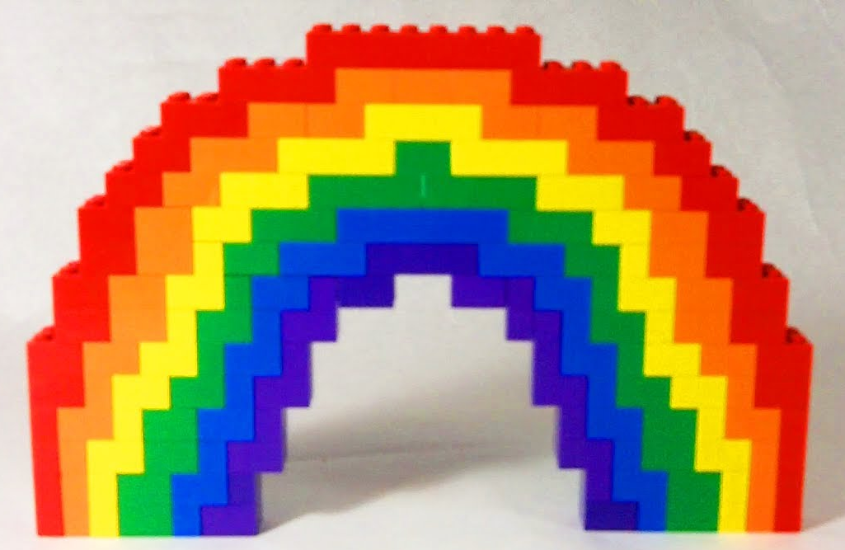  Wash our hands https://www.youtube.com/watch?v=OZ3oSvfiwU4 Jack Hartman
10-20 mins | Story time/Read a text - https://www.theguardian.com/books/gallery/2020/apr/04/gruffalo-axel-scheffler-and-julia-donaldsons-coronavirus-cartoons#img-1
Tuesday
Approx. Timing | Suggested Activity | Activity Plan
10 mins | Mindfulness | This could be a colouring activity, a breathing exercise or a quiet handwriting exercise. Something that gets your child ready for a day of learning.
30 mins | PE with Joe Wicks /  Eat breakfast with family | This is where your child will have their bagels (if in school) it is a good time to do Joe Wicks PE if you are at home or you could use this time to sit as a family and eat breakfast together. It is important to teach children how to hold a conversation or have good table manners.
30-40 mins | RWI  oy toy for a boy  oi spoil the boy  Wash hands | Quick dash of sounds already know look at sound sheet. Look at oy oi sounds and sound out the words with that sound in and let your child blend the word (e.g. toy you sound out t-oy and your child says toy/spoil you sound out s-p-oi-l and your child says spoil) repeat with 3 more words oy (boy, enjoy, coy) oi (foil, soil, coin, join) . Fred talk (sound out with your child) 3 or 4 words with the oy oi sound in them. Spell some of the words oy oi using Fred fingers. Write sentences for 3 or 4 of your words - ensure you have a capital letter finger spaces and a full stop. To make your sentence longer add a conjunction (for and now but or yet so) e.g. Today the boy played with his large toy. He joined the pieces of foil. With a conjunction: Today the boy played with his large toy then he joined the pieces of foil. OR Today the boy played with his large toy, but he joined the pieces of foil. Let’s all wash our hands https://www.youtube.com/watch?v=S9VjeIWLnEg song
15-20 mins | Break Time
10 mins | Times tables Practice | You should practise times tables every day. You could use times table rock stars or Numbots https://play.ttrockstars.com/auth/key/6458fd5b63f9d7df122b36b2a1ad3afc Reception: doubling and halving  https://play.numbots.com/#/account/school-login-type Year 1&2: 2s, 5s, 10s
30-40 mins | Maths Activity | https://www.ictgames.com/mobilePage/shiftingShapes/index.html shifting shapes game. Today we are going to look at 3D shape (sheet at the end of planning to use). Can you remember these shapes and what properties they have (faces/vertices and edges)? E.g. a cube has 6 square faces, 12 edges and 8 vertices look at the 3D shapes images and write how many faces (flat surfaces) they have? How many vertices (corners- where two or more edges meet)? And how many edges (where two flat surfaces meet)?  Number of the week challenge: (sheet at end of planning) What is greater than 7 What is less than 7  7 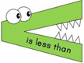7
30-40 mins | Lunch time
30-40 mins | Topic-Lego  English Activity | https://www.tripadvisor.co.uk/AttractionProductReview-g186338-d11451658-LEGOLANDR_Windsor_Admission_with_Transport_from_London-London_England.html look at the images of Legoland and discuss what they might like to see at a Legoland theme park. Draw a new ride and describe or look at images (see sheet at end of planning) and choose one or two to write about. Don’t forget what you need in a sentence 1. Capital letters. 2. Finger spaces. 3. Full stops. 4. Conjunctions (for and nor but or yet so – FANBOYS). 5. Adjectives (descriptive words) e.g. huge, fast, exciting, daring, adventurous, scary. 6. Neat writing. 7. Letters sitting on the lines or though the lines appropriately.
10 mins | Golden Mile/Physical Activity
30-40 mins | PSHE/Topic | Getepic GO With YOYO  Imagine you are a Lego figure – What would you look like? – Discuss and design your own image (on the Lego figure at the end of planning). Wash our hands song
10-20 mins | Story time/Read a text Getepic - look at one of the Lego books.
Wednesday
Approx. Timing | Suggested Activity | Activity Plan
10 mins | Mindfulness | This could be a colouring activity, a breathing exercise or a quiet handwriting exercise. Something that gets your child ready for a day of learning.
30 mins | PE with Joe Wicks /  Eat breakfast with family | This is where your child will have their bagels (if in school) it is a good time to do Joe Wicks PE if you are at home or you could use this time to sit as a family and eat breakfast together. It is important to teach children how to hold a conversation or have good table manners.
30-40 mins | RWI  Wash hands | https://www.ictgames.com/mobilePage/forestPhonics/index.html looking at the set 3 sounds choose one - can you see anything in or outside the classroom/house that has your chosen sound in it? Write down the word. Is your best friend correct? E.g. ow bow ai train ea bean i-e like oa oat u-e tube ear tear ire hire ur purse er hammer oi oil a-e name o-e phone. Challenge – can you find any of the set 2 sounds and write as a word or use a book and play I spy for them …if you see any how many can you write down  handwriting https://www.ictgames.com/mobilePage/skyWriter/index.html Have you written your letters correctly? Look at the sky writer or write the letter for your child to copy. Is it sitting on the line properly? E.g. a c e i m n o r s u v w x z Is it tall enough? E.g. b d h k l t Are the tails below to line? E.g. g j p q y (if you are drawing in flour make sure you draw a line so your child can place the letter correctly).
15-20 mins | Break Time
10 mins | Times tables Practice | You should practise times tables every day. You could use times table rock stars or Numbots. https://play.ttrockstars.com/auth/key/6458fd5b63f9d7df122b36b2a1ad3afc Reception: doubling and halving https://play.numbots.com/#/account/school-login-type Year 1&2: 2s, 5s, 10s
30-40 mins | Maths Activity | Today we are going to look at shape (template at the end of planning to use). There are shapes all around us. What 2D or 3D shapes can you find around your house/classroom? Take images or draw what you have found and write underneath what these shapes are? E.g. I found a clock it is a 2D circle, I found a tin of beans it is a 3D cylinder. Challenge – Can you find and name at least one of every shape 2D and 3D shape (that are pictured at the end of the planning)? If you can find more, what shape did you find the most of and was it a 2D or 3D shape?  Number of the week challenge: (sheet at end of planning) Using the + - signs, how many number sentences can you make?
30-40 mins | Lunch time
30-40 mins | Topic - Lego  English Activity | Today we are going to make a leaflet about Lego land (using the images at the end of the sheet). If you have iPad or computer look at the map online. What information do you think you should include? And what rides? Do you want to add the new ride that you described? What did you call it? What we need to make a great leaflet  1. Space. 2. Images 3. Readable 4. Quality 5. Inform. Leaflets are used to: Inform. A good leaflet will tell us exactly what is offered from the park and provide information in a small space. ... A leaflet should entice its reader into wanting to go to Legoland. Once you have written your leaflet you might like to draw the images yourself. Don’t forget what you need in a sentence 1. Capital letters 2. Finger spaces 3. Full stops. 4. Conjunctions (for and nor but or yet so – FANBOYS) 5. Adjectives (descriptive words) e.g. huge, fast, exciting, daring, adventurous, scary. 6. Neat writing 7. Letters sitting on the lines or though the lines appropriately.
10 mins | Golden Mile/Physical Activity
30-40 mins | PSHE/Topic | Get epic GO With YOYO  Little book of friends First draw a picture of one of your friends (sheet at end of planning). Can you write their name? Next write what you like to do together in a sentence and explain why. E.g. I enjoy playing hopscotch with my friend because she is great at taking turns and teaching me how to play. Then think about what qualities does your friend have that makes them a good friend, list at least nine things E.g. caring, kind, helpful, shares, gentle, sympathetic, thoughtful, considerate, supportive, calm, tender, understanding, compassionate, unselfish, loyal, cool, affectionate, empathetic, magnanimous.
10-20 mins | Story time/Read a text/getepic story.
Thursday
Approx. Timing | Suggested Activity | Activity Plan
10 mins | Mindfulness | This could be a colouring activity, a breathing exercise or a quiet handwriting exercise. Something that gets your child ready for a day of learning.
30 mins | PE with Joe Wicks /  Eat breakfast with family | This is where your child will have their bagels (if in school) it is a good time to do Joe Wicks PE if you are at home or you could use this time to sit as a family and eat breakfast together. It is important to teach children how to hold a conversation or have good table manners.
30-40 mins | RWI  air that’s not fair  are care and share  Wash hands | Quick dash of sounds already know look at sound sheet. Look at air are sounds and sound out the words with that sound in and let your child blend the word (e.g. air you sound out h-air and your child says hair/share you sound out sh-are and your child says share) repeat with 3 more words air fair, chair, stairs/ are care bare compare. Fred talk (sound out with your child) 3 or 4 words with the air are sound in them. Spell some of the words air are using Fred fingers. Write sentences for 3 or 4 of your words - ensure you have a capital letter finger spaces and a full stop. To make your sentence longer add a conjunction (for and now but or yet so) e.g. The girl thought it was not fair that the boy had all the cake. She said, “you need to share”. With a conjunction: The girl thought it was not fair that the boy had all the cake, so she said, “you need to share”. OR The girl thought it was not fair that the boy had all the cake and she said, “you need to share”.  Let’s all wash our hands https://www.youtube.com/watch?v=S9VjeIWLnEg
15-20 mins | Break Time
10 mins | Times tables Practice | You should practise times tables every day. You could use times table rock stars or Numbots https://play.ttrockstars.com/auth/key/6458fd5b63f9d7df122b36b2a1ad3afc Year 1&2: 2s, 5s, 10s  https://play.numbots.com/#/account/school-login-type Reception: doubling and halving
30-40 mins | Maths Activity | 3D shape Can 3D shapes ROLL, STACK OR SLIDE? – Can you find two objects that are the same shape and then test to see if they roll (for this you can use a book and two bricks to prop it up to make a slope)? Did the sphere roll? Did the cylinder roll? Did the cube roll? Did the cone roll? Did they stack (one on top of the other same shapes only)? And did they slide? Record your findings (on the sheet at the end of the planning). CHALLENGE: Can you test any other 3D shapes?  Number of the week challenge: (sheet at end of planning) Is 7 an odd or even number? Can you share it? Can you write the number 7 as a word? Write the number 7 correctly.
30-40 mins | Lunch time
30-40 mins | Reading comprehension  English Activity | Reading comprehension End plastic Pollution  Our planet Our planet is special, and we must look after it. Everyone has an important role of keeping it clean and safe. We also have a responsibility to look after everything that lives in it including people, plants and animals. However, one huge problem that we have is plastic pollution which is damaging our planet and many animals living on it.  What is plastic pollution Plastic pollution is when plastic that has been thrown away ends up in oceans and rivers, on the beaches and in the countryside. Many things we use every day are made of plastic. Plastic is very cheap and strong so when it is thrown away it lasts a long time and is hard to get rid of. Lots of plastic ends up in the ocean where it traps and harms fish and other sea animals.  What can we do There are lots of things we can do to end plastic pollution.  - Reuse a water bottle instead of buying a new one  - Don’t use plastic straws for drinking  - Carry shoppoing in fabric bags, not plastic ones  - Talk to your family about buying things that are made of other materials, not plastic  - Talk to your head teacher or school council about how your school can use less plastic.  Did you know?  - The amount of plastic that humans use every year weighs the same as 30 million elephants  - By the year 2050 there could be more plastic in the world’s oceans than fish!  Questions  - Whose responsibility is it to look after the earth and everything on it?  - Find and copy the words that describes plastic?  - What is bad about plastic pollution?  - Where does the plastic end up?  - What can you do to help?  Write your answers to your questions in a sentence using Capital letters, finger spaces and full stops. If you are not sure of your answer carefully read the comprehension piece again for the answers.
10 mins | Golden Mile/Physical Activity
30-40 mins | PSHE/Topic (For PPA day) RE  Links to cultural development and Fundamental British values. | Special ways of living – Islam - Explain to the children that Muslims believe they have a duty to pray to Allah (God) five times a day: at dawn, midday, late afternoon, after sunset and late evening. The children could draw hands on blank clock faces to show daily Muslim prayer times. The mu’adin calls the people to prayer from the top of the minaret. https://www.youtube.com/watch?v=CDqAdiQ4eW8 clip of the adhan (call to prayer).  To prepare themselves for prayer, Muslims perform an elaborate washing ritual called wudu. The order is as follows: hands, mouth, nostrils, face, arms, top of the head, ears, feet. Imagine what it would be like to perform wudu and mime the washing actions. https://www.youtube.com/watch?v=93kjPt6ajaA steps of wudu. Can you write down the steps? (See images at end of planning to support).
10-20 mins | Story time/Read a text
Friday
Approx. Timing | Suggested Activity | Activity Plan
10 mins | Mindfulness | This could be a colouring activity, a breathing exercise or a quiet handwriting exercise. Something that gets your child ready for a day of learning.
30 mins | PE with Joe Wicks /  Eat breakfast with family | This is where your child will have their bagels (if in school) it is a good time to do Joe Wicks PE if you are at home or you could use this time to sit as a family and eat breakfast together. It is important to teach children how to hold a conversation or have good table manners.
30-40 mins | RWI  or shut the door  aw yawn at dawn  Wash hands | Quick dash of sounds already know look at sound sheet. Look at or aw sounds and sound out the words with those sounds in and let your child blend the words (e.g. for you sound out f-or and your child says for /claw you sound out c-l-aw and your child says claw) repeat with 3 more words or fork, born, forward, torn /aw gnaw, jaw, dawn, paws. Fred talk (sound out with your child) 3 or 4 words with the or aw sounds in them. Spell some of the words or aw using Fred fingers. Write sentences for 3 or 4 of your words - ensure you have a capital letter finger spaces and a full stop. To make your sentence longer add a conjunction (for and now but or yet so).  Let’s all wash our hands https://www.youtube.com/watch?v=S9VjeIWLnEg song.
15-20 mins | Break Time
10 mins | Times tables Practice | You should practise times tables every day. You could use times table rock stars or Numbots https://play.ttrockstars.com/auth/key/6458fd5b63f9d7df122b36b2a1ad3afc Reception: doubling and halving https://play.numbots.com/#/account/school-login-type Year 1&2: 2s, 5s, 10s
30-40 mins | Maths Activity | Today we are going to look at shape. We are going to use shapes to make a picture with either 2D and/or 3D shapes. To create an image use 2D shape. Cut and stick your shapes together (take images). For 3D shapes you might want to use clean recycling materials e.g. inner toilet rolls (cylinders) small boxes (cubes or cuboids) 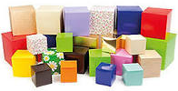 Toblerone tube (triangular prism) 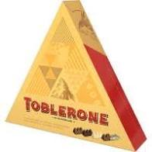  Number of the week challenge: (sheet at end of planning) part of the 7 times table. What else can you tell me about the number 7?
30-40 mins | Lunch time
30-40 mins | Topic/English Activity | What can you make with the Lego bricks you have? … Describe and draw. Telling your adult what colours, size and thickness of brick you have used and where you have placed the bricks (using the sheet at the end of the planning – describing Lego bricks). Write down how you have made your Lego creation, a step at a time, like the instructions sheets that come inside the Lego packs. E.g. Step 1 First you need a thin red brick with six bumps on the top in a line. Step 2 Next add … (you could draw the picture to go with your creation). What do you need to write an instruction? 1. Use short sentences. 2. Put your points in logical order. 3. Make your sentences to the point (specific). 4. Put the most important item in each sentence at the beginning. 6. Say one thing in each sentence.
10 mins | Golden Mile/Physical Activity
30-40 mins | PSHE/Topic | 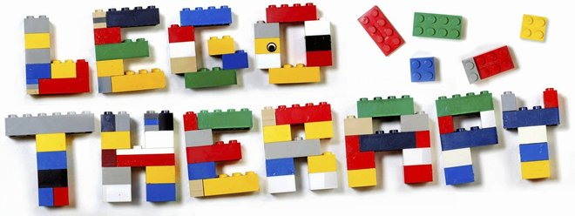 Lego therapy  Collect up the same bricks for you and your architect. Can you listen to the architect (your adult) and put your bricks in the right place? As your architect builds the same as you are building (without you looking at what is being built). Have you built the same thing at the end?
10-20 mins | Story time/Read a text getepic one of the Lego books
Name the 2D shapes
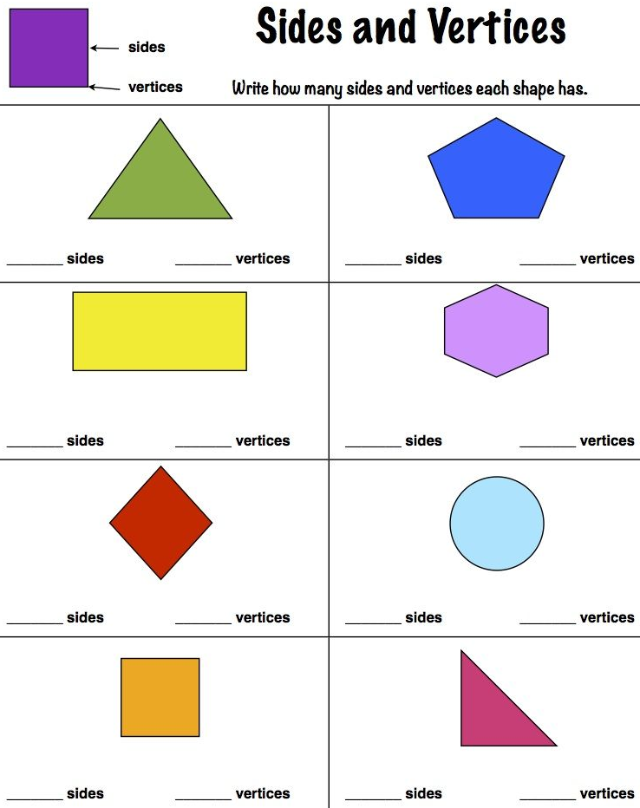
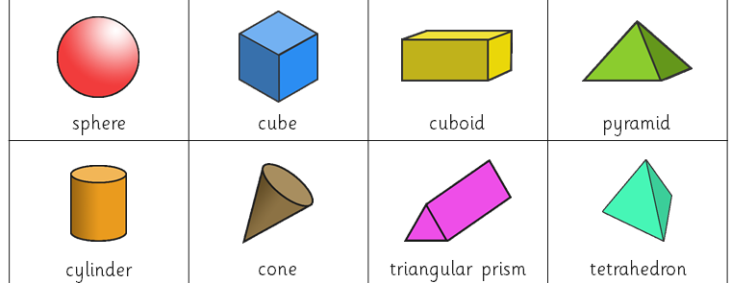
Name the 3D shapes and their properties (how many faces? How many vetices/corners? How many edges?)

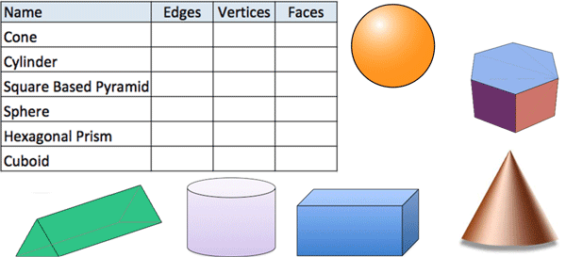

Finding out about Lego
If you're like most kids, you probably love to play and build things with those colourful little blocks we all know as LEGO® blocks. Let's learn a little more about the history of these fun toys.
LEGO® blocks are just part of the overall line of construction toys made by the Lego Group, a company from Denmark. In addition to the colourful interlocking plastic blocks we're all familiar with, other LEGO® toys include gears, figurines, wheels and various other parts that allow kids to construct all sorts of buildings, machines, vehicles and even robots.
The great thing about LEGO® toys is that they can be taken apart and reused over and over again to make new creations. LEGO® toys have become so popular all over the world that they have expanded from just toys to include movies, games, competitions and even LEGO®-themed amusement parks!
The Lego Group got its start in the carpentry workshop of Ole Kirk Christiansen. He started making wooden toys in 1932. He began calling his company “Lego" in 1934, based upon the Danish phrase leg godt, which means “play well."
The Lego Group began making its famous plastic interlocking blocks in 1949. At first, they were not very popular, because customers still preferred wooden toys. Over time, though, they became very popular as the company made them part of an overall system of toys that kids could use to build an unlimited variety of things.
The LEGO® block design still in use today was patented on January 28, 1958. Blocks from that year are still compatible with blocks made today. The Lego Group takes great pride in manufacturing precise pieces that fit firmly together yet can be easily taken apart.
Since 1963, LEGO® blocks have been made from a special plastic called acrylonitrile butadiene styrene or ABS. Over the last 50 years, the Lego Group has produced over 400 billion LEGO® blocks. That's enough LEGO® blocks for every person in the world to have over 60 LEGO® blocks!
Today, the Lego Group also makes LEGO® robotic sets that help young students learn how to build and program robots in competitions, such as the Junior FIRST LEGO® League and the FIRST LEGO® League.
Some children may also be familiar with the video game series that have developed from the popularity of LEGO® toys. Some of these popular video games include Lego Star Wars, Lego Indiana Jones, Lego Batman and Lego Rock Band.
The popularity of LEGO® blocks has grown so much over the years that these toys can be found in all parts of popular culture and even in schools as educational toys. In 1998, LEGO® blocks were inducted into the National Toy Hall of Fame.
Wonder Words (13) modern, design, patented, construction, interlocking, Plastic, Figurine, Carpentry, Workshop, Compatible, Precise, Firmly, Robotics
Ready to build? Chances are that you have access to LEGO® blocks at home or at school. Can you build a fantastic LEGO® creation that will impress all your Wonder Friends? If so, take a picture of it and post it to Facebook. We can't wait to see what you come up with!

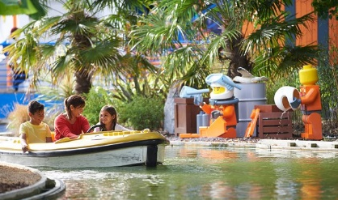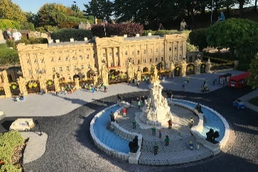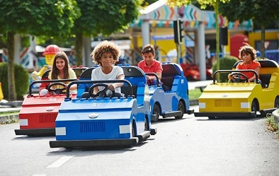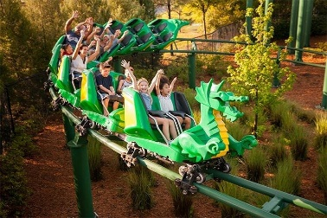
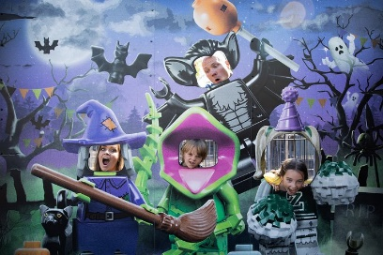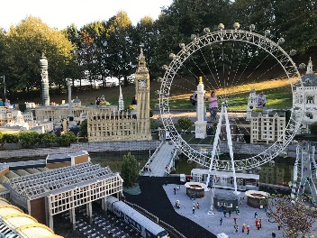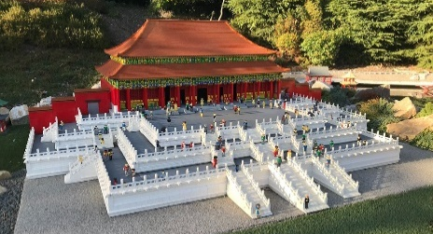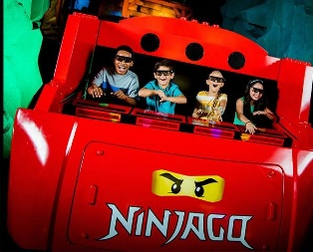
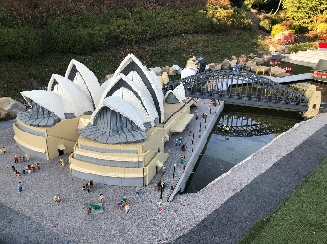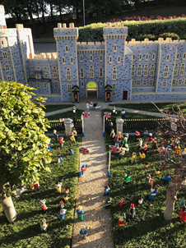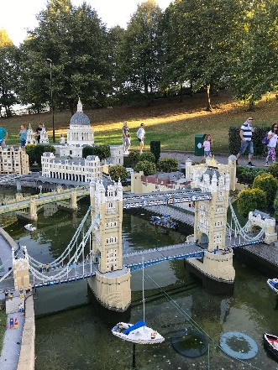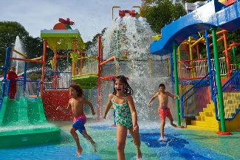
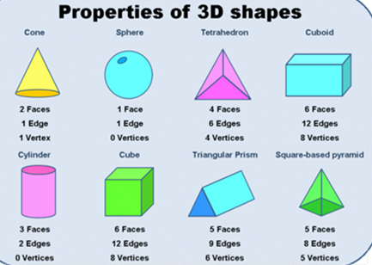
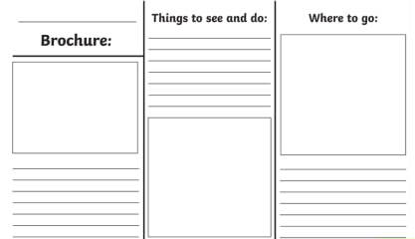
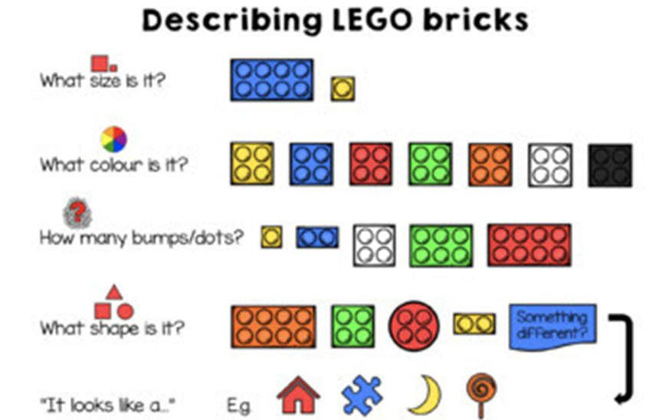
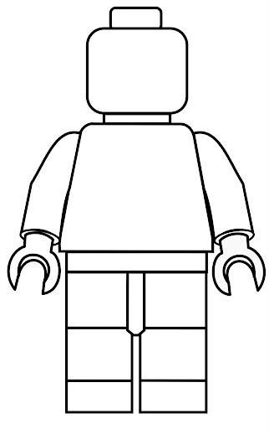
Design you as a Lego character.

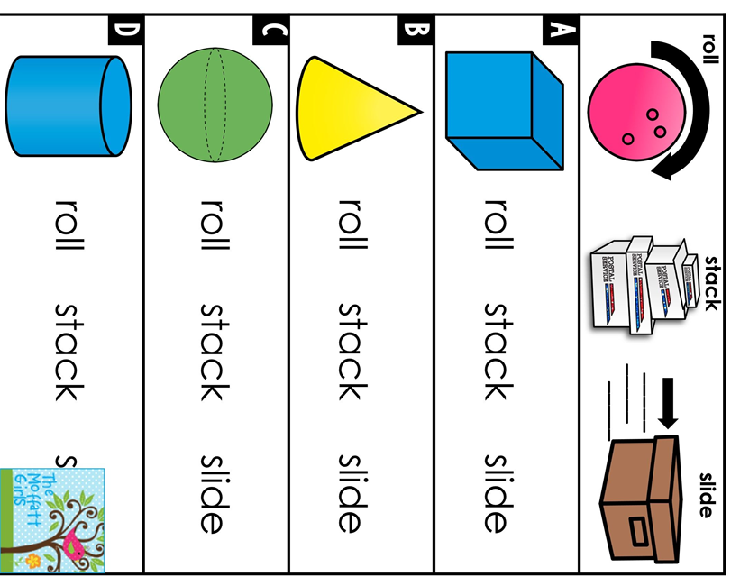

Read Write Inc. Spelling Sounds charts
Consonant sounds
b | c | ch | d | f | g | h | j | l | m | n | ng  nk
b  bb | c  k  ck  ch  que | ch  tch | d  dd | f  ff | g  gg  gue | h | j  g  ge  dge | l  ll  le | m  mm  mb | n  nn  kn  gn | ng  nk

p | qu | r | s | sh | t | th | v | w | x | y | z
p  pp | qu | r  rr  wr | s  ss  se  c  ce  sc | sh  si  ti  ci  ch | t  tt | th | v  ve | w  wh | x | y | z  zz  s  se

Vowel sounds
a | e | i | o | ay | ee | igh | ow | oo
a | e  ea | i  y | o  a  u  o  ou | ay  a-e  ai  eigh  a  ei  ey  aigh | ee  e-e  ea  e  y  ey  ei  ie | igh  i-e  y  ie  i | ow  o-e  oa  o  oe | oo  u-e  ew  ue  oe  ou

oo | ar | or | aw | air | ir | ou | oy | ire | ear | ure
oo | ar  a | or  ore  oor | aw  au  a | air  are  ear | ir  ur  er | ou  ow | oy  oi | ire | ear  eer | ure

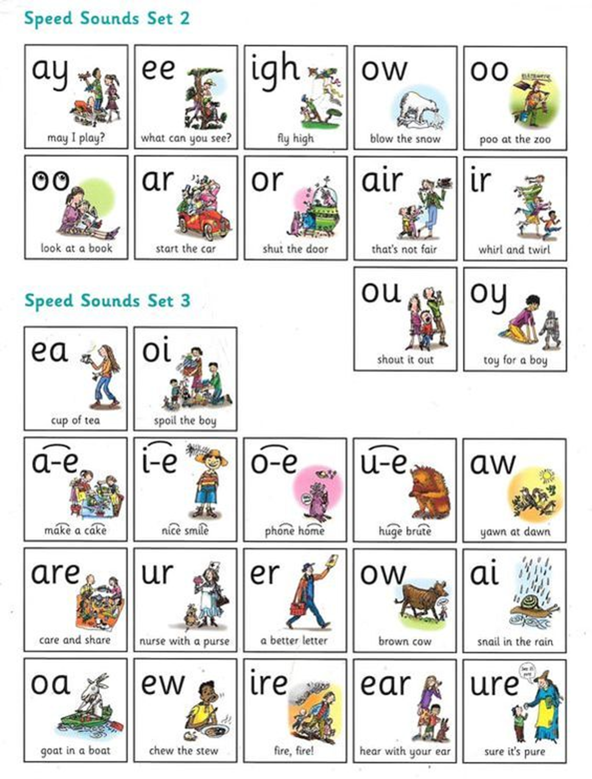

Monday  Draw a tally mark to represent 7 | Tuesday  What is greater than 7?  7  What is less than 7?  7  This week’s number 7 | Wednesday using the + - signs  How many number sentences can you make?
Draw a group of things to represent 7  (e.g. 7 hearts or 7 teddies) |  | + =7 | 7- =
Thursday  Is 7 an odd or even number? Can you share it? | Friday 7 times table  1x7= 71=  2x7= 142=  3x7= 213=  4x7= 284= | What else can you tell me about the number 7?
Can you write the number 7 as a word?

Write the number 7 correctly.
Number of the week challenge

