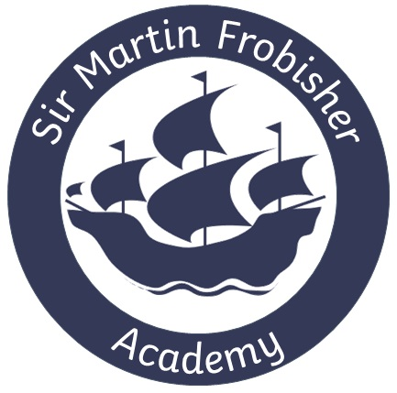

Sports Premium Funding Plan

2020 - 2021

Sir Martin Frobisher Academy Sports Premium Funding
Schools receive PE and sport premium funding based on the number of pupils in years 1 to 6.
Schools must use the funding to make additional and sustainable improvements to the quality of physical education (PE), physical activity and sport offered.
This means that the premium should be used to:
- develop or add to the PE, physical activity and sport activities that the school already offers
- build capacity and capability within the school to ensure that improvements made now will benefit pupils joining the school in future years

Key Indicators for the use of Sports Premium
- Key indicator 1: The engagement of all pupils in regular physical activity – Chief Medical Officer guidelines recommend that primary school children undertake at least 30 minutes of physical activity a day in school.
- Key indicator 2: The profile of PESSPA being raised across the school as a tool for whole school improvement.
- Key indicator 3: Increased confidence, knowledge and skills of all staff in teaching PE and sport.
- Key indicator 4: Broader experience of a range of sports and activities offered to all pupils.
- Key indicator 5: Increased participation in competitive sport.

Accountability
The Head Teacher and Senior Leadership Team will regularly monitor, evaluate and review the strategies and interventions put in place for Sports Premium and report to the Governing Body on its progress and impact.

Estimated Pupil Premium Funding 2020/2021
TOTAL Sports Premium budget: £18,217 |  |  |  | Actual Spend: £9,248.54 (COVID-19 Reduction)  Carry Forward to 2021/2022: £8,968.46
Sports Premium Grant Planned Expenditure 2020/2021
Objective | Activity | Cost | Who is it focused on? |  | Expected impact | Review 1  Dec 2020 | Review 2  Mar 2021 | Review 3  July 2021
To ensure all pupils access at least 30 minutes of physical activity a day. | Implement “activity” time throughout the day in which children are physically active (for at least 1 session)- including the Daily Mile.  Trim trail to be purchased for development of physical activity. | Certificates/medals  £24.95  Swimming booster costs £1437.10 (Summer Term)  £4,165 | All year groups |  | Children’s fitness improves.  Behaviour at lunchtime is positive. | Not currently happening due to COVID-19 Pandemic. | Not currently happening consistently due to COVID-19 Pandemic. | Since lockdown has ended, children are timetabled to regular activity each day.
To raise the profile of Physical Education, School Sport and Physical Activity (PESSPA). | Deputy Headteachers to lead PE across the school. | PE Teachers  Col U- £2,880 | All members of school community |  | Parent, pupil and staff feedback shows that there is a high-level engagement in sport across the school. | Not currently happening due to COVID-19 Pandemic. | Not currently happening consistently due to COVID-19 Pandemic. | PE scheme adapted and being followed.
To increase confidence, knowledge and skills of all staff in teaching PE and sport. | CPD to support, coach and model high quality PE across the school. | CPD  Col U- £2880 - see above section | Teaching Staff |  | Teachers feel confident in teaching PE | Not currently happening due to COVID-19 Pandemic. | Not currently happening due to COVID-19 Pandemic. | Teachers received CPD to develop confidence around teaching PE.
To increase the number of different sports available to the children. | Purchase additional sports resources/equipment so that a variety of sports can be offered to the children. | Sponge balls  Tennis balls  Hoola hoops  Netball bibs  Netball nets  Ball pumps  £141.49 | All Year groups |  | Children’s fitness improves.  More children engage in a variety sports outside of the school day. | Equipment bought but not yet showing impact due to COVID-19. | Equipment bought but not yet showing impact due to COVID-19. | Children able to access a greater range of sports as have access to more equipment.
To increase the range and frequency of sports and physical activity based extra-curricular clubs delivered by teachers/coaches | Teachers to offer various sports  Sports coaches to come in to teach specialist sports | Cost of PE staff  Col U- £2880 - see above section  Premier- £600  Equipment  £141.49 - see above section | All year groups |  | Parent, pupil and staff feedback shows that there is a high-level engagement in sport across the school. | Unable to run cross-curricular events/ after school clubs due to COVID-19. | Unable to run cross-curricular events/ after school clubs due to COVID-19. | Some sports clubs run Summer Term. Children enthusiastic about these.
To increase awareness of mental-health and wellbeing across the school | Implement “activity” time throughout the day in which children practise mindfulness (for at least 1 session). | Mindfulness programme to follow. | All year groups |  | Children are more aware of mental-health and strategies to support their wellbeing. | Difficult to measure due to COVID-19. | Difficult to measure due to COVID-19. | Mindfulness time used across the school each day. Some children are beginning to improve with mindfulness.
 | Total Cost (reduced because of Covid) | £9,248.54

