Special Educational Needs Information Report
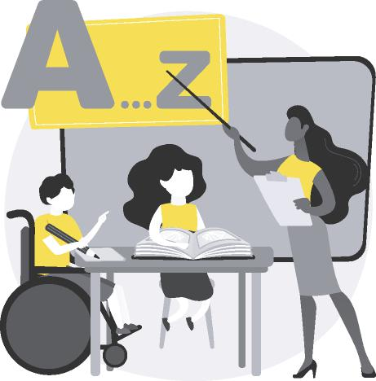
YEAR 2021-2022
APPROVED BY GOVERNERS:
All schools are committed to adopt a similar approach to meeting the needs of all children including those with special educational needs. There is a shared expectation that all pupils, regardless of their specific needs, should be offered inclusive teaching which will enable them to make the best possible progress and ensure they can participate in the wider aspect of school life.

Your children are our priority.
At Sir Martin Frobisher Academy we strive to create a sense of community and belonging for all our pupils. We have an inclusive ethos with high expectations and suitable targets, a broad and balanced curriculum for all children and systems for early identification of barriers to learning and participation. The school has adopted The Thrive Approach and TPP as part of our SEMH provision across the school.
What support do we offer:
What we offer children with SEN is different for every child. The support is designed by the appropriate staff members working alongside the child, the child's parents and carers and, where necessary, outside agencies
(Engagement Facilitator, Speech and Language Therapist)
4 categories of need:
The Code of Practice specify 4 main areas of SEN that include a range of difficulties. We offer provisions and interventions to support progress where children have these difficulties. Some examples are as follows:
Communication and Interaction: Speech and Language therapist, NELI
Cognition and Learning: Precision teaching
Social, Emotional and Mental Health Difficulties: Thrive
Sensory and/or Physical: Physiotherapy exercises.

HOW SKILLED ARE THE STAFF IN MEETING THE NEEDS OF MY CHILD?
An ongoing programme of training and gap analysis is in place taken from staff
SWOT analysis to ensure that all teachers and support staff have appropriate
skills and knowledge to support provision with SEN. Recent training has
covered:
Effective Interactions (scaffolding)
Precision Teaching
Read Write Inc Phonics Intervention
Setting targets (provision map)
The priority training for the year 2021-2022 is collaborative learning.
The SENCO actively engages in a range of opportunities to share best practice
and keep abreast of local and national initiatives and policy to support pupils
with SEN.
The school also seeks advice and guidance from the local cluster and trust
schools and other relevant agencies to help school staff support the needs of
your child to review, evaluate and develop provision.
We have staff with specialised expertise and qualifications including:
Thrive practitioners
Advanced Autism Teacher
Speech and Language Therapist
NELI trained practitioners (Speech and language)
Learning Mentor
Psychological mental health first aid practitioners

WHAT LEVEL OF SUPPORT DOES MY CHILD NEED?
The needs of most children will be met by highly inclusive quality first teaching. It is the responsibility of the class teacher to adapt the curriculum to meet the needs of individual children. However, there may be times when children require provision that is 'additional to' and 'different from' their peers. This may mean they need a provision map/ one page profile, ONE PLAN or EHCP.
Wave 3
Additional highly
personalised
interventions
Wave 2
Additional interventions to enable children to work at age related expectations or
above
Wave 1
Inclusive quality first teaching for all.

WHAT IF MY CHILD IS STILL NOT MAKING PROGRESS?

03
If, despite an increased level and nature of support, it is evident that the severity and complexity of your child's needs require provision beyond that can be offered by our own resources, a request for an Educational Health Care Plan Needs Assessment may be requested.
The SENCO will explain the process to you and show you how to find out more information and details of parent support organisations which can support you.
Children who have special educational needs but whose needs are met by quality first teaching and targeted interventions will be on a provision map which outlines their provision and support.
For many children, targets will be
connected to their learning and will specifically link to a child's individual needs - this will be different for everyone. The most important point is:
Targets depend on the needs of the child.

A child with the most complex Special Educational Needs and/or Disabilities will have a ONE PLAN which sets out targets that are currently being worked on and what ADDITIONAL PROVISION is put in place for that child. The content of the ONE PLAN is negotiated with the child, family and if necessary other professionals.

ADDITIONAL PROVISION
The school offers many different forms of additional provision. This can include additional in class support, out of class support or interventions, one-to-one support, flexible groupings, resources, learning mentor. Additional provision is overseen by the SENCO and is implemented by teachers and teaching assistants.
Additional provision depends  the needs of the child.  ACCESS ARRANGEMENTS | on

For some pupils additional arrangements and adjustments can be made to enable them to fully access statutory tests. This might include additional time, rest breaks or use of a scribe. The SENCO, teacher or phase leader will talk to you if it is felt that your child would benefit from additional arrangements.
04

WHO SHOULD I CONTACT TO DISCUSS THE CONCERNS OR NEEDS OF MY CHILD?
Class Teacher / Phase Leader
Responsible for:

Adapting and refining the curriculum to respond to strengths and needs of all pupils.
Checking the progress of your child and identifying, planning and delivery of any additional support required to support progress.
Contributing to devising learning pupil provision maps and one plans to prioritise and focus on the next steps to required for your child to improve learning.

The class teacher should always be the first person you speak to if you have any
concerns.
SENCo: Priscilla Wadsworth Responsible for: | 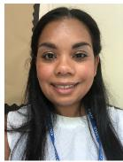
Coordinating provision for children with SEN and developing the school's SEN policy.
Ensuring that parents are: involved in support their child's learning and access, kept informed about the range and level of support offered to their child and included in reviewing how their child is doing.
Consulted about planning transition to a new class or school.
Liaising with a range of agencies outside of school who can offer advice and support pupils overcome any difficulties.
Providing advice and facilitating training to ensure that that all staff are skilled and confident about meeting a range of SEN.
Head teacher: Debbie Conroy
The day to day management of all aspects of the school, including provision made for pupils with SEN.
SEN Governor: Shelley Corsinne
Supporting school to evaluate and develop quality and impact of provision for
pupils with SEN across the school.

TRANSITIONS
Children with SEN can become particularly anxious about 'moving on' so we seek to support successful transition by:
When starting the school:
We will contact the child's early years provider, childminder or, if they do not attend a setting, the parents/carers and make arrangements to visit the child in their current provision and gain information from their key worker. We have a transition programme in place for children and their parents/carers to visit the school. A range of transition videos and information are posted on Tapestry to be accessed.
When moving between classes:
An information sharing meeting will take place with the receiving teacher. If appropriate, there will be opportunities for you and your child to visit the new class staff and classroom prior to starting the new class.
When moving to secondary school:
The SENCO will contact with the Year 7 leader and/or SENCO once a school has been named. Multi-agency meetings maybe arranged to create a more detailed transition plan alongside the parents and the pupils. Successful arrangements and interventions will be shared and are documented on the ONE PLAN/ ONE PAGE PROFILE.
When moving to another school:
We will contact the School SENCO and share information about special arrangements and support that has been made to help your child achieve their goals. We will ensure that all records are passed on as soon as possible.
For further information about Special Educational Needs in Essex, please see the Essex Local Offer. Here you will find information on applying for an EHCPNA and SENDIASS.

