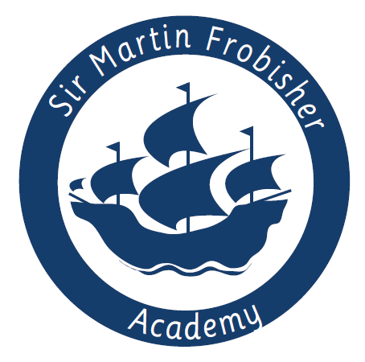
Class Teacher Vacancy

Overview
Are you an outstanding, innovative, exciting and reflective practitioner who can make a difference to children’s lives? Do you have high expectations? Are you passionate about providing an excellent education for all children, including those with additional needs and more confident learners? Are you looking for a unique opportunity? If so, our children need you!

At Sir Martin Frobisher Academy we are looking for a Class Teacher. We are looking for individuals who are up for a challenge and want to get stuck in with all aspects of our academy life!

Post Title: | Class Teacher (With subject leadership responsibility for experienced candidate)
Contract type: | Permanent
Location: | Sir Martin Frobisher Academy
Working hours: | Full-time
Start date: | 1st September 2022
Salary: | Main/Upper Teachers’ Pay Scale

About us:
Sir Martin Frobisher Academy is a primary academy in Jaywick, Essex, with a current roll of 191 children. Many of our families live on the Brooklands Estate in Jaywick Sands, the most deprived area in Britain, and we are pleased once again to be able to offer transport to families most in need to ensure these children can attend school regularly.

Sir Martin Frobisher converted to academy status in Sept 2016 and now has a stable senior team who are dedicated to moving the school forward while ensuring the individual needs of the children are met. The Academy has a high number of PPG, FSM and SEND children and our staff are dedicated and understanding of this and of the unique community that Sir Martin Frobisher Academy is at the heart of. New strategies have been implemented, both just before and during COVID, and we are excited to begin to monitor the impact these will have on children’s learning. We also run an Early Bird club before school and all children are offered breakfast before they start school.

The children at Sir Martin Frobisher Academy are lively, enthusiastic, endearing and a joy to work with. The sense of community is strong and we are hoping to move back to a Local Governing Body in September 2022 following a period of intervention.

About the role:
As a newly appointed member of the Sir Martin Frobisher family, you will help shape our future direction. You will work alongside our Senior Leadership Team and other Sir Martin Frobisher staff to help create an exciting and vibrant school, where all children thrive, regardless of their background.

You will work in partnership with other Class Teachers and Learning Support Assistants. You will be supported by experienced Senior Leaders and be part of the wider Academy Team.

There is potential for your role to grow and adapt with the academy over the coming years, with leadership opportunities as the school develops and improves. You will be expected to lead a curriculum subject area, unless you are an NQT.

What we’re looking for:
We are looking for an outstanding classroom practitioner who would be happy to work in either Key Stage 1 or 2. You will be someone who is highly driven and motivated, has an eye for detail and can work flexibly and creatively.
The successful candidate will have:
- An excellent understanding of the National Curriculum, age related expectations and early learning goals
- The motivation and resilience to achieve the very best for the children in our care and be relentless in the pursuit of excellence
- Proven experience as an effective good and outstanding classroom teacher
- Experience of working with children of different ages within Key Stage One and Two
- Excellent communication skills and a good sense of humour
- A positive team player and be able to use your own initiative
In return we can offer:
- A firm commitment to you and your professional development
- Friendly, supportive, enthusiastic and hardworking colleagues, staff and Governors
- A growing learning community
- Encouragement to develop new ideas and the opportunity to make a real difference
-Coaching and mentoring from a member of the academy’s Senior Leadership Team
-Fantastic Trust-wide CPD opportunities
-Vast opportunities for career progression

Ideally you will also have experience of working with children with SEND. You will be able to scaffold and extend children's learning and develop their independent thinking through appropriate questioning as well as being committed to consistency, inclusion and challenge. You will be part of a unique community as well as being part of the largest primary Multi-Academy Trust in the country.

The children at Sir Martin Frobisher need a stable and committed staff, who really believe in them and are willing to do whatever it takes to ensure they receive the best teaching and the widest opportunities possible. In return, you will see that our children are enthusiastic, keen to learn and rewarding to teach.

You will be welcomed and supported as part of an established team. We are a very happy and friendly school.

How to apply
We hope you will take the time to find out more about our academy and experience our warm welcome. For further information about the role, or to arrange an informal discussion, please contact the head teacher, Miss Debbie Conroy, on 01255 427073 or email head.teacher@smfa.org.uk.

Completed REAch2 Academy Trust application forms should be sent directly via e-mail to head.teacher@smfa.org.uk by midday on Wednesday 18th May 2022.

Short-listed candidates will be invited to attend an interview on Tuesday 24th May 2022. Sir Martin Frobisher Academy is committed to safeguarding and promoting the welfare of children, young people and vulnerable adults and expects all staff and volunteers to share this commitment. The successful applicant will be subject to an enhanced DBS check.

